Worldwide Winter Holidays
Visual Presentation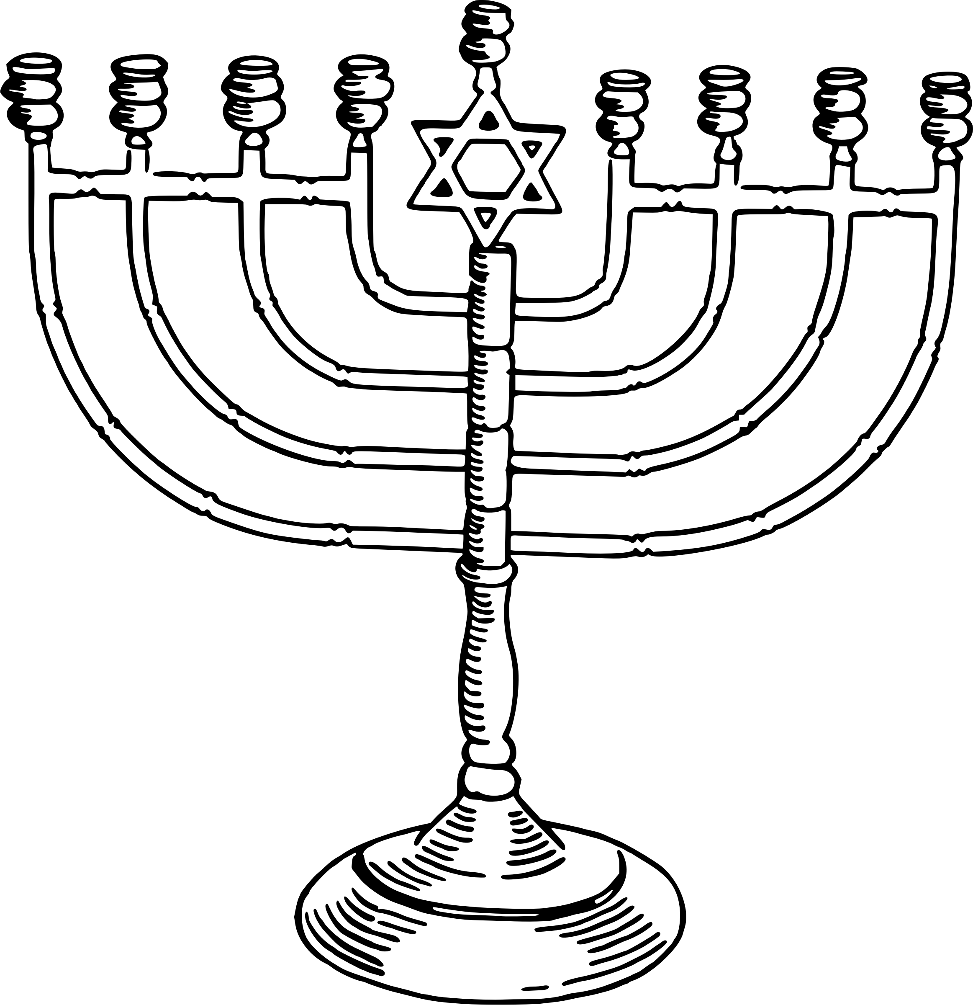
WHAT?
Building on the skills we have learned accessing databases through the school website (remsslibrary.com) and using other online digital resources, you will need to create a short, primarily visual, PowerPoint presentation about some of the traditional holidays and celebrations that are or will be underway across the globe in the coming months.
HOW?
Each of you is going to be provided some initial background information about your tradition, holiday or celebration and you will need to add to it to give yourself enough research material for a 3 – 4 minutes presentation. You will be given class time and support to complete the presentation, and you can work with a partner. If you choose to work with a partner you will then need to present for 5 – 7 minutes and each person will need to present.
HELP
Below are some guiding questions you may want to refer to in order to keep you focused and organized with your research.
  - Where does the celebration take place and why is it significant for the local population?
  - How and when is it celebrated?
  - What are the origins of the tradition, celebration or holiday?
  - Are there any culturally significant costumes, jewelry, ceremonies or foods involved in the winter celebration?
  - Are there any symbols associated with the celebration? If so, what are their significance?
PRESENTATION
  - Your PowerPoint should mostly be images with a title and perhaps a few small points.
  - You are welcome to use cue cards to help you remember your points when presenting, but please don’t stand to the front of the class and read directly from a paper. The purpose is to practice “presenting information”, not “reading information”

PRESENTATION RUBRIC
1 | 2 | 3 | 4
Research is minimal or inaccurate and does not fully meet the assignment requirements. | Research is acceptable but there are errors, and minimally meets the assignment requirements. | Research is good and there aren’t any errors. It meets the assignment expectations. | Research is excellent and it there is additional information that adds to the overall project.
Visuals are minimal and aren’t relevant or don’t add to the presentation. | Visuals are adequate and compliment the presentation satisfactorily. | Visuals are relevant to the presentation and add to the overall quality of the assignment. | Visuals are excellent and clearly reflect what is being presented in the assignment.
Accuracy of the information is questionable or unreliable. | Accuracy of the information is satisfactory, however it is vague or irrelevant. | Accuracy of the information is good and is relevant to the assignment. | Accuracy of the information is excellent, relates to the topic and adds to the overall quality of the work.
Presentation of the projects is unrehearsed or the presenter does not know the material. | Presentation of the project is acceptable, however the presenter appears unprepared. | Presentation of the project is good. The presenter is prepared and understands what they are presenting. | Presentation is dynamic and informative. The presenter is very well prepared and has an excellent understanding of the topic.
The presenter does not follow the instructions very well and is missing a lot of required information. | The presenter does not completely follow the assignment instructions, however most of the elements are present. | The presenter follows instructions well and nearly all of the required elements of the assignment are present. | The presenter has every element of the assignment and follows instructions perfectly.
Student: Topic:
Research / 4
Visual appearance of your research project / 4
Accuracy of information / 4
Presentation of information / 4
Following instructions / 4

