Name:
Parts of Speech and Prepositions
What are the 9 parts of speech and what do each of them do?
Part of Speech | Function | Example
Why does it sometimes list TEN parts of speech and other times only EIGHT??
Why TEN? Which parts of speech can be broken into two separate parts of speech? What are they?

Why EIGHT? Which part of speech can also be considered an adjective?

Identify the parts of speech in the following sentences:
1) She loves fluffy cats, but I prefer sparkly unicorns.

2) Thomas ran quickly to the corner store to get his mother a large bottle of milk.

3) Wow! She is really smart! She spelt every word on her spelling test correctly.
Let’s focus on Prepositions!!
List 7 of the most common prepositions:
1)
2)
3)
4)
5)
6)
7)
Prepositions typically come before a noun phrase. What are 4 examples of noun phrases?
1)
2)
3)
4)

Prepositions of Place (at, in, on)  When do we use…? AT IN ON  AT is used for ______________________  IN is used for _______________________  ON is used for _____________________ | Prepositions of Time (at, in, on)  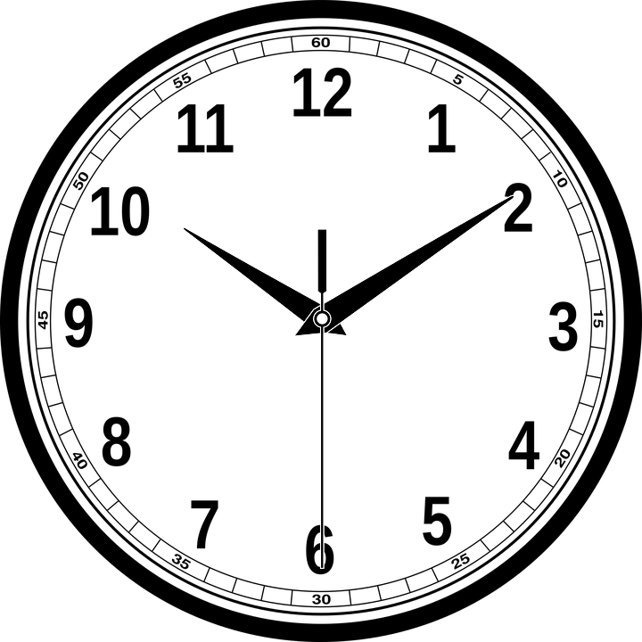  When do we use…? AT IN ON  AT is used for ______________________  IN is used for ______________________  ON is used for _____________________

Choose the correct preposition of place for the following sentences.

- Janelle and Dawson went to Whistler and stayed ______ a five-star hotel.
- Murray and Doug attended Brookswood Secondary, which is ____ South Langley.
- Tyler was ____ his roof fixing the broken chimney.
- Kevin was ____ home when the alarm went off.
- Damien has an apartment ____ Kelowna, BC.
- Patricia left her phone ____ the table ____ the restaurant.
- A Science professor ____ SFU received an award for her excellent research.
- Evan was born ____ July 8th, 1979.
- Marcus and Jordan met ____ the soccer field.
- Davin and Clyde visited their mom ____ Montreal, and she met them ____ their favourite park.
- Rob and Dave went out ____ 3 o’clock to pick up Colin from the bus stop ____ Parker Street.
- Every morning ___ 6:00am, Paulina gets ___ her car and drives to the Community Centre to swim ____ the pool.
- ____ 1989, Mr. Main was ___ the tenth grade ___ Earl Marriott Secondary ___ Surrey.
- ____ Christmas Day, Glenn always wakes up early and waits ___ the sofa for his mom and dad to bring him cookies and milk.
- Tony was running late, and the store was closing ____ 9pm, so he rushed and got into an accident ___ the corner of 8th Avenue and Smith Street.
- Corina and Jodi were playing ____ the pond when Jodi accidently fell ____.
- Marc met his wife ____ the daycare and they picked up their daughter who was waiting outside ___ a bench.
- Greg has lived ___ 9 different countries, but never ___ Japan.
- Tracey and Michael celebrated their 15th wedding anniversary ___ Tuesday, ___ the cafe where they first met.
- Hayden and Dominic arrived ____ different times to the shopping mall. Hayden arrived ____ car, but Dominic arrived earlier ____ bus.

