B.C. man forced to leave N.B. after dream of moving to P.E.I. sours at Confederation Bridge

‘You've got five hours to get out of New Brunswick,’ Kaden Webb recalls being told by conservation officer
Rachel Cave · CBC News · Posted: May 30, 2020 9:00 AM AT | Last Updated: May 30
Kaden Webb packed his belongings and his dog in his camper van and journeyed from British Columbia to his new home on Prince Edward Island. However, he was denied entry into the province because he couldn't produce the proper documentation. (Submitted/Kaden Webb)
At 33, Kaden Webb had given up on ever owning a home in pricey Greater Vancouver.
But Prince Edward Island seemed friendly and affordable.
So, with the help of his family, he purchased 11 acres on the Island.
The thrill of owning his own plot soon had him talking non-stop about building an energy-efficient home. He was so energized, he said, his brother and father also caught the dream.
"My dad ended up purchasing another property with my brother, about 12 acres," said Webb.
"With my whole family, we own 23 acres."
After making some preparations, including loading up a camper van with food and water and his dog, Webb set out to cross the country about two weeks ago.

Trouble at the border
He described it as a beautiful trip and largely uneventful until he reached the Quebec-New Brunswick border, where he got stopped by authorities.
He said he told New Brunswick officials that he was moving to P.E.I. and he showed them his driver's license and his P.E.I. property deed.
He was then allowed to pass into New Brunswick.
After being denied entry onto Prince Edward Island, Kaden Webb was told by a New Brunswick conservation officer waiting for him on the other side of the Confederation Bridge that he had five hours to leave the province. (Submitted/Kaden Webb)
He said he also vividly remembers that they told him if he didn't get onto Island, for any reason, he would have to self-isolate in New Brunswick for 14 days.
To Webb, that was an important and reassuring point — if he couldn't reach P.E.I., he could stay in New Brunswick as long as he followed the rules.
He said he entered New Brunswick at about 5:30 p.m. Wednesday. Twenty-four hours later, Webb said he arrived on the P.E.I. side of the Confederation Bridge.
Again, he said he produced his P.E.I. deed.
However, he couldn't prove that he had sold any property in another province. That's a requirement under the rules of P.E.I.'s state of emergency travel restrictions, which ban non-essential travel.
However, people who are moving to the Island permanently can apply for an exception if they provide the required documentation.
"I never owned a home in B.C.," said Webb.
Nor could he provide a copy of a cancelled rental agreement. That's because he was unemployed and couldn't afford rent, he said. Instead, he said he'd been living in his camper van and sometimes with relatives.

'You have five hours to get out of New Brunswick'
Because he didn't have the necessary paperwork, Webb said the P.E.I. authorities denied him entry. Then, he said, they threatened him with arrest if he didn't leave immediately.
Back on the New Brunswick side, things went from bad to worse.
"On the [New Brunswick] side of the bridge, there were multiple officers waiting for me," said Webb.
"They said they were going to arrest me and put my dog in a shelter even though I told them he was an emotional support animal."
Webb said a conservation officer told him he could be fined up to $10,000 if Webb didn't start driving right away.
Webb choked up while describing what happened next.
"I said, 'I'm tired. I've been driving across Canada. I don't want to drive right now,'" Webb said.
"He said, 'It doesn't matter. You have five hours to get out.'
On Friday, Webb said he'd spent a sleepless night in his camper van and told CBC News he still hasn't mustered the energy to drive back to Quebec.
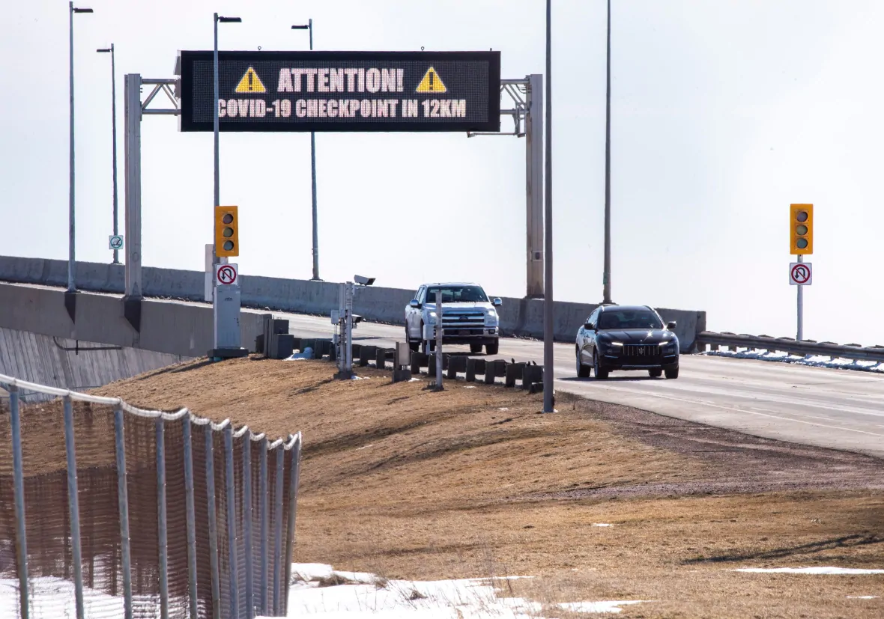
Kaden Webb crossed the Confederation Bridge, but that's as far onto the Island as he would get before being turned back. (Brian McInnis/CBC)

Try again, says P.E.I. official
P.E.I. Public Safety spokesperson Vicki Tse said the province is trying to manage a large volume of requests from people who want exceptions from the non-essential travel ban.
Webb said he's still hopeful that someone will reconsider his case.
He said he's been corresponding by email with the P.E.I. Emergency Measures Organization since March.
In one message that he shared with CBC News, Webb is informed that in order to assess his application, he must produce a dated sale of agreement for his home in B.C., a dated purchase agreement for his land in P.E.I. and a signed agreement with a contractor for construction of his home.
Webb said he continued to communicate with EMO officials by phone while driving across Canada, but he never got a written approval to enter P.E.I. to present at the point of entry.
Tse said her best advice to any individual in the situation that was described to her would be to go through the proper channels and try again.

Comprehension Questions:
1) On the first page, one of the sentences reads “But Prince Edward Island seemed friendly and affordable.” What does affordable mean? Use it in a sentence.
Meaning:
Sentence:

2) How many people in Kaden Webb’s family purchased property in Prince Edward Island, who were they, and how many acres did each of them buy?

3) At which provincial border did Mr. Webb first run into some trouble, and what happened?

4) Why wasn’t Mr. Webb allowed to enter Prince Edward Island?

5) What is your opinion about what happened to Kaden Webb?

