Bilingual Baking Activity
This activity will include both Math and French and will be the major project in each subject for the Second Term. In groups of 2 – 3 we are going to combine fractions, with French and baking to come up with project which will be “amusant, fantastique et délicieux!”
Working in groups of 2 – 3 people, you will need to come up with a baking recipe that we can completed at school. A group member will demo the lessons first by naming the ingredients in French, then providing the directions in English, and each member of the group must present in each language. You will prepare your cookies or treats in class, then volunteers will take care of the baking for us.
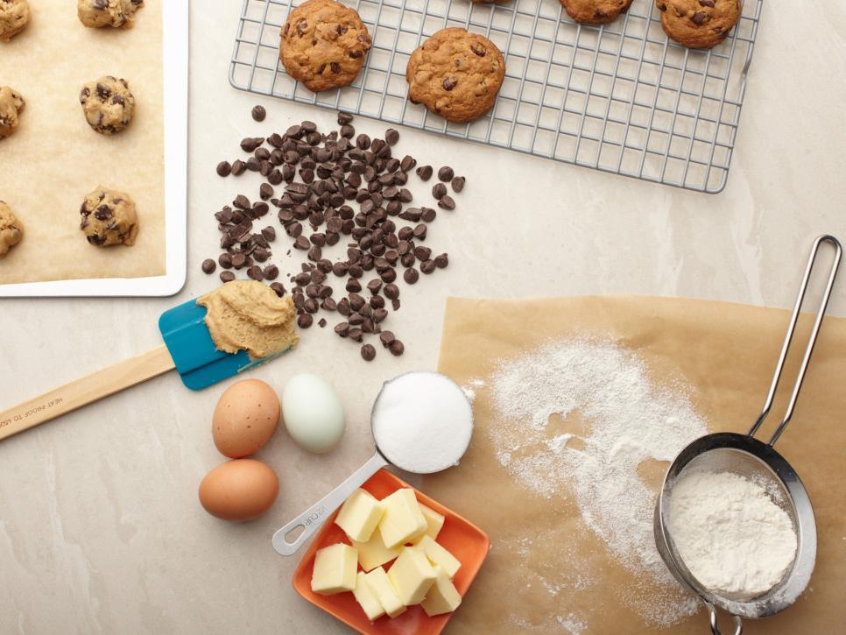
Your group will be responsible to create a bilingual recipe, with instructions both in English and French. Your recipe should be for a serving of about 24 cookies or treats, and each group will need to bring enough ingredients to make at least 2 times that yield (approx. 48 cookies or treats).
The groups will be divided into two or possibly three baking and presentation days. Each participating group member will bring home at least one cookie, or treat, from every one of the groups. Once all the presentations are complete, and the treats are baked and ready, all the recipes will then be compiled, and shared as a class cookbook.

TO DO LIST:
- Step 1: find 1 - 2 partners that you can rely on, and work well with.
- Step 2: locate a recipe that does not feature peanuts, or any other
- allergens that can affect your classmates.
- Step 3: have your recipe approved by Mr. Main (first come, first serve - no repeats!)
- Step 4: once your recipe is approved, it’s time to research the names of ingredients in French
- Step 5: do the math necessary to yield 48 - 60 cookies or treats
- Step 6: begin delegating who will bring what to the presentation
- Step 7: hand in your recipe, and a list of which student is bringing which ingredients and baking supplies
- Step 8: HAVE FUN!!

