Twelve Rules of Life – Group project
Watch 12 Rules of Life (Animated) 12 minutes
https://www.youtube.com/watch?v=PFo9-7VX2K8
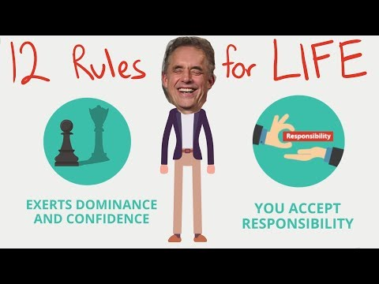
Jordan Peterson’s Twelve Rules for Life
1. Stand up straight with your shoulders back.
2. Treat yourself like someone you are responsible for helping.
3. Choose your friends carefully.
4. Compare yourself against yourself from yesterday.
5. Don’t let your children do anything that will make you or society dislike them.
6. Set your OWN house in order before criticizing others.
7. Life is supposed to be meaningful.
8. Tell the truth - don’t lie.
9. Assume that the person you are listening to might know something you don’t.
10.Be precise in your speech.
11.Do not bother children when they are skateboarding.
12.Pet a cat when you encounter one on the street.
In class assignment details:
Step 1 - Working as a small group (maximum of 3), each student equally creates a list of twelve rules to live by.
Step 2 - Plan out and create a short 2 – 3 minute visual presentation that you can shares with your classmates. It can be a video, a PowerPoint or created on poster paper. *Be prepared to explain the story behind any or all of your group’s rules.*

Group Members: ___________________________________
Our group’s 12 Rules of Life:
Rule 1
Rule 2
Rule 3
Rule 4
Rule 5
Rule 6
Rule 7
Rule 8
Rule 9
Rule 10
Rule 11
Rule 12

Time Considerations:
Take about 20 minutes to discuss and settle on your group’s “12 Rules of Life” (There should be a story behind each rule.)
Take about 10 minutes to decide how you will present your information.
Spend the final 30 minutes putting together your presentation or practicing.
*All groups will present after the classroom break.*

