French 8 - Term 2 - Tâche Finale
"French Fashion Show"

For your final task we are going to set up a fashion show! WOO HOO!!

You must have at least 4 people to use as your models. This won't be as hard as it sounds. Your classmates will help, because they will need your help too.

Here is a sample format for your fashion show:

"Voici Arlette, elle a 14 ans et elle n'aime pas la musique
country. Elle porte une jolie jupe rose et noire avec une
chemise bleue foncée et des boucles d'oreilles en argent."

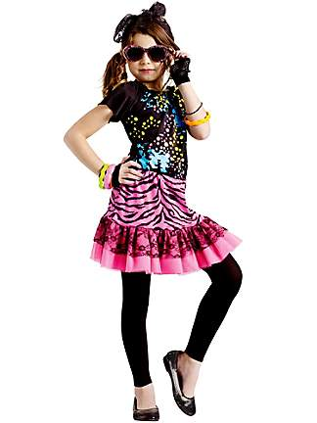
You will need to:
- introduce each of your models,
- include their age and…
- provide at least one more bit of information.
- You will then describe at least 3 articles of clothing or accessories.
*** The personal information about your model DOES NOT need to be true, but the description of your model's clothing should be. ***

Have fun with this assignment, find some
outrageous clothing and do your best!!

The script for your fashion show need to be complete by no later than Monday, January 21st, so that I can correct it, and return it to you with enough time to practice your script and get your models organized for presentation on February 4th. ** If you are planning to be away on Feb. 4th, you will need to do your presentation earlier.**

