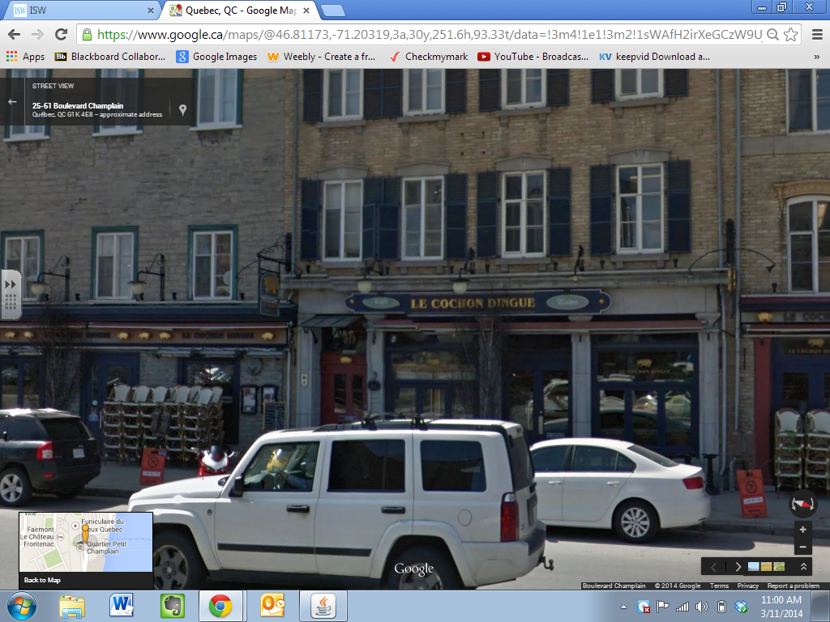
“Le Cochon Dingue” – “The Crazy Pig” – Restaurant
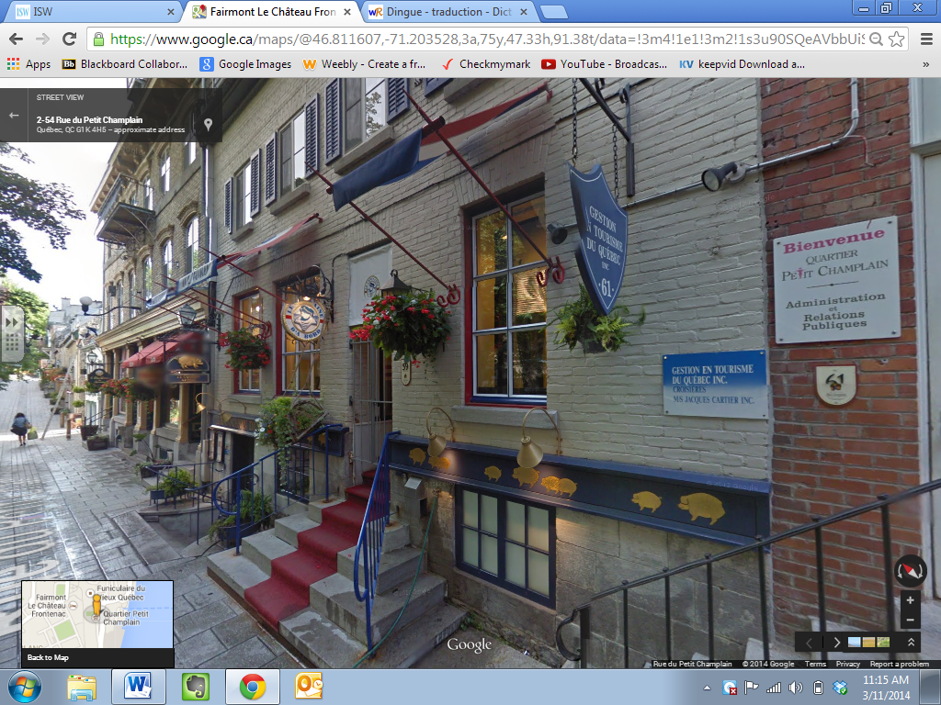
Bienvenue - Quartier Petit Champlain – Administration et Relations Publiques
Welcome – Little Champlain Quarter (area) – Administration and Public Relations
Gestion en Tourisme du Quebec – Quebec Tourism Management

