Resurrecting the Woolly Mammoth? – (www.teachingkidsnews.com)
A woolly mammoth carcass that was frozen in ice for 40,000 years may make it possible for scientists to bring the extinct species back to life.
The mammoth was found embedded in ice on a remote island off northern Russia in May 2013. The ice had preserved the body so well, a liquid that looked like blood oozed out of it when it was first discovered.
Scientists were very excited because fresh blood cells may contain DNA, or genetic information about the mammoth. If scientists can find the mammoth’s complete DNA, they might be able to clone the animal.
(Cloning is a process that makes it possible to create an exact copy of an animal. Scientists take genetic information from the cell of one animal and insert it into the egg of another animal. The second animal then gives birth to an exact genetic copy of the first animal.)
After the mammoth carcass was dug up, scientists spent three days studying it and taking samples of its blood and tissues. Then they froze it again to prevent it from rotting.
Sooam, a biotechnology company from South Korea, is studying samples taken from the mammoth to see if they can find enough genetic information to try cloning it.
Woolly mammoths have been extinct for 10,000 years. Many scientists think they could learn a lot more about the species if they could study a living example. Other scientists think cloning an extinct species is a bad idea.
Dr. Tori Herridge, a scientist at the Natural History Museum in London, England, helped study the woolly mammoth’s body. She doesn’t think scientists should try to clone it.
She said that scientists would need an Asian elephant to be the clone’s mother. This means they would have to keep several elephants in captivity while they experiment with the cloning process. But Asian elephants are endangered, and don’t do well in captivity.
Dr. Herridge said that giving birth to a woolly mammoth could be dangerous for the elephant mother. Once the baby was born, it would also have to live in captivity. In addition, it would be the only mammoth in the world, and woolly mammoths preferred to live in herds.
Dr. Herridge thinks scientists can learn a lot just by studying the remains of the woolly mammoth.
So far, scientists have found out that the woolly mammoth, who they nicknamed Buttercup, was 2.5 metres tall and about 50 years old when she died. By studying the growth rings in her tusks, they can tell that she gave birth to eight calves. Her teeth show that she had dental problems.
By examining the contents and bacteria found in her intestines, scientists can tell she ate grassland plants like dandelions and buttercups. They think she died after she became trapped in the peat bog and then was attacked by predators such as wolves.
Insung Hwang is one of the scientists at Sooam. He said they have not yet found complete DNA in any of the samples, but they have found pieces of DNA that could be pieced together.
He added that it will take scientists a long time to analyze the genetic information from the mammoth, and even longer before they actually try cloning the animal.
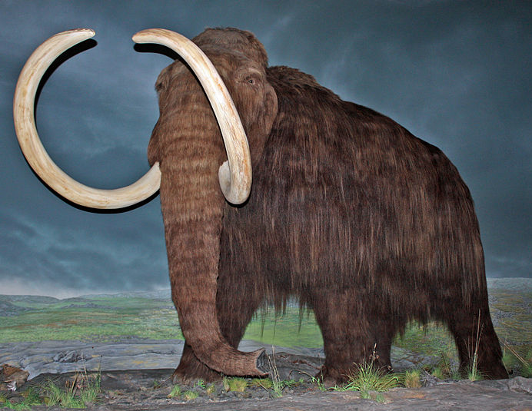
Related sites
Wikipedia entry http://en.wikipedia.org/wiki/Woolly_mammoth
Information and videos about woolly mammoths from BBC Nature http://www.bbc.co.uk/nature/life/Woolly_mammoth#intro
Mammoths and Humans http://mammoth.psu.edu/society.html

