The 2020 Summer Olympics
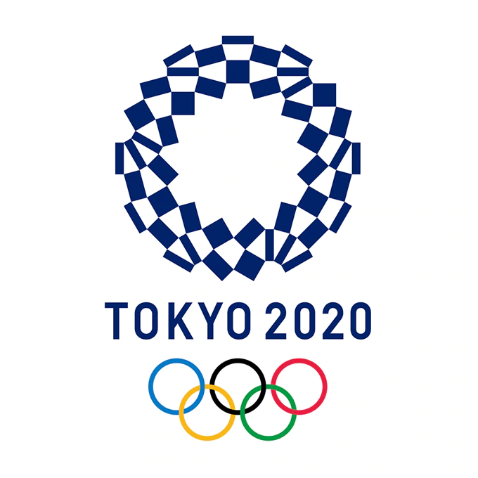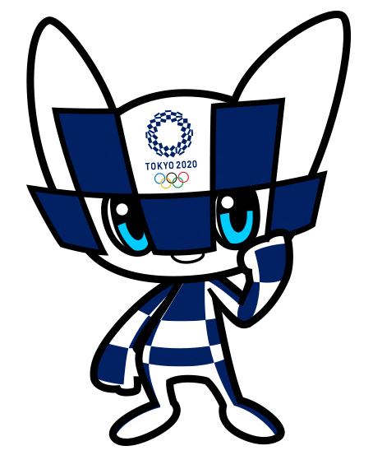
For hours, days, months, and years, Canada’s best athletes have been practising their swim strokes, training on beams, and pushing hard to beat their best times in track and field.
Their one goal? To win medals for Canada at the 2020 Summer Olympics in Tokyo, Japan.
Then, a tiny microbe named COVID-19 changed everything.
As the coronavirus sickened and killed people around the globe, Japanese and Olympic officials conceded that they had no choice. The risk of the disease infecting athletes, their families, and stadiums full of fans was great enough. The risk of the same people returning home to spread the disease was even greater.
Postponed!
On March 24, just four months before the start of the Olympics, the word came down. The Games would be postponed. Some 11,000 athletes from 206 nations would be staying home.
The globe’s biggest sporting event is now scheduled to take place in Tokyo exactly one year late. If all goes well, it will run from July 23 to August 8, 2021. Despite the date change, however, it will still be known as the Tokyo 2020 Olympic Games.
“It’s a weird mindset,” said Taylor Ruck, a Team Canada swimmer who won two Olympic bronze medals in 2016. “You worked four years – or at least this whole
year – grinding every day trying to do what you can to get ready for this summer.
“[But] it is definitely the right decision. It’s better… just to focus on what we can do to stop the virus from spreading.”
'A Difficult Jigsaw Puzzle'
Now, sports federations around the world are scrambling to adjust their global calendars to the new dates. Qualifying events will have to be rearranged. International meets will have to be coordinated all over again.
“There are a lot of pieces of a huge and very difficult jigsaw puzzle,” said Thomas Bach, president of the International Olympic Committee (IOC).
A Worst-Case Scenario
Still, everyone is prepared to adjust. After all, a delay is not so bad. We can wait a year, right? The problem: The Games may not take place even then. Decision-makers say they will make that call down the road.
What’s the hang-up? It could take as long as 18 months to develop and circulate a COVID-19 vaccine. If one isn’t ready by July 2021 and the disease is still taking its deadly toll, the 2020 Olympics will be scrapped altogether, says Tokyo 2020 President Yoshiro Mori.
That would make it the fourth cancellation in the 124-year history of the Games. Olympics didn’t take place in 1916 during World War I, or in 1940 and 1944 during World War II.
Expenses And Complications!
Problems would escalate if the Games are finally cancelled. Thousands of tickets have been sold to people around the world. They’ll want refunds for those, and for plane tickets and hotels. Fans and businesses alike will feel the pinch.
As well, Japan has invested at least $10 billion in the Games. A delay could add as much as $6 billion to the price tag. But a cancellation would be worse. Leases on sports venues and contracts with employees would have to be ended – all at a cost. Yet there would be no tourist dollars to ease the pain.
Waiting And Wondering
Meanwhile, athletes who quit jobs or put school on hold to train are losing out on sponsorships and scholarships. For now, their biggest competitor is a nasty microbe.
“This is a gamble for mankind,” said Mr. Mori. “If the world triumphs over the virus and we can hold the Olympics, our Games will be many times more valuable than past Olympics.”

The Games, Then and Now – The Dimming of a Flame
The Olympics originated some 3500 years ago in Greece, but were abolished by the Roman Emperor in 394 A.D. Over 1500 years later, 24-year-old Baron Pierre de Coubertin of France reintroduced the Games. He believed that sport encourages peace among nations.
The first modern Summer Olympics were held in 1896. The first Winter Games took place in 1924. Summer and Winter Games now alternate on even-numbered years.
The Olympic rings are the official symbol of the Olympic movement. The five interlacing blue, yellow, black, green, and red rings set upon a white background represent the union of five continents – Australia, Europe, Asia, Africa, and the Americas – and the meeting of athletes throughout the world. The colours were chosen because at least one of these shades is found on the flag of every country.
The most revered symbol of the competition is the Olympic flame. According to Greek mythology, Prometheus stole the sacred fire from the gods and brought it to Earth, where it became the symbol of human reason, freedom, and creativity. For each Olympics, a new flame is started in the ancient Olympic stadium in Olympia, Greece, using a parabolic mirror to focus the rays of the sun. The flame is used to light a torch that is passed from runner to runner in a relay.
The flame arrived in Japan on March 25, the day after the Games were postponed. Japan and the IOC decided to keep it on display in hopes that the Games will resume next year. They called it a “light at the end of the tunnel” – a reference to better times after the coronavirus.
Unfortunately, the light can’t be seen now. A state of emergency was declared in Tokyo and other regions due to a spike in COVID-19 cases, forcing the flame to be removed from public viewing.

Vocabulary
abolish: to officially get rid of a law, system, practice, etc.
concede: to admit something usually in an unwilling way
International Olympic Committee: a non-governmental sports organization based in Switzerland. Founded in 1894, it is responsible for organizing the Summer and Winter Olympics.
microbe: an extremely small living thing that can only be seen with a microscope
revered: respected or admired

Comprehension Questions
Answer the following in complete sentences: (When done put your answers in your HAND IN folder)

1. When and where did the Olympics originate?

2. What happened to the Olympic Games in 394 A.D.?

3. Explain who Baron Pierre de Coubertin was. What he did do some 120 years ago?

4. Where and when did the first modern Summer Olympic Games take place?

5. Which organization is responsible for organizing the Olympics? Where is this organization based?

6. Where were the XXXII Summer Olympic Games scheduled to take place?

7. How many athletes were expecting to participate?

8. Where and when are these Summer Olympics now scheduled to take place?

9. What reasons did organizers give for this postponement?

10. List at least two financial impacts that would result if the Tokyo Games were completely cancelled.

