Weekly Learning Schedule: May 25th - 29th
 | MONDAY | TUESDAY | WEDNESDAY | THURSDAY | FRIDAY
09:00 – 10:00am | Morning warm up:  -Read the Weekly Learning Schedule  -Find three things in your room that can be measured for perimeter & area.  -Answer these 3 Qs:  1)What are the three items?  2) What are the dimensions of the items?  3) What are the perimeter and area of each item?  Post your answers on “Division 7 Students Only” Teams page BEFORE our morning Meet Up | Numeracy: Perimeter and Area Worksheets  Go to the Numeracy / Math Page and download or write out the questions for all three Math Perimeter and Area worksheets.  We will go through some of the answers during our Wednesday meet up.  *I will post all the answers on Wednesday afternoon so that you can check the rest of your work.* | Literacy: Reading Groups  9:00am – 9:20am  Grumpy Gorillas  9:20 – 9:40am  Awesome Otters  9:40 – 10:00am  Speedy Slugs | Thursday Early Morning Meet Up:  9:00am – 10:00am  -Explain “Real Estate- Area and Floor Plans” Assignment  -Explain “Design your own Woodblock Racer” project  -Question / Answers  -Fun and Games (time permitting) | Mr. Main is assisting Students at JKE and will not be available for online help after 10:30am.  Numeracy: “Real Estate – Area and Floor Plans” assignment.  Go to the Numeracy / Math Page and download the worksheets.
10:00 – 10:30am | (Health) Body Break:  PE with Joe – Fitness Challenge:  www.tinyurl.com/uhu3wfv  *Put scores in HAND IN folder.* | (Health) Body Break: Yoga with Adriene: Day 4 of 30 of Yoga  https://tinyurl.com/nahx5p9 | Relax: Take some time to unwind. Find a preferred activity that you can calm you down. (Listen to some music, draw, take a nap or go for a walk.) | (Health) Body Break: Workout with the “Junkyard Dog “– NBA legend Jerome Williams  https://youtu.be/PdSrJbmaZik | Health & Wellness:  JUST DANCE Time!!  Choose 2 or 3 Just Dance videos from the Health and Fitness page and get your dance on!!
10:30 – 10:45am | Snack Break | Snack Break | Snack Break | Snack Break | Snack Break
10:45 – 11:30am | Monday Morning Meet Up 10:45am – 12:00pm  -Warm Up activity  -Go through WLS  -Review of how to measure Perimeter and Area | Literacy: “Hubble Telescope” Reading Comprehension & Questions  *Download from the Literacy page and please put your answers in your Hand In Folder* | Wednesday Morning Meet Up 10:45am – 11:30  -Review Answers from Hubble Telescope reading and Perimeter & Area Worksheets | Literacy: Epic Reading App. “Fiona’s Luck”  Read the book, then take the Quiz.  *Take a screenshot or photo of your quiz score and put it in your Hand In Folder.* | Work Time: Use this time to either work on your “Real Estate Assignment”  or  Continue with your “Woodblock Racer Project” and move to Step #2 - Details & Colour”
11:30 – 12:00pm | Monday Morning Meet Up (Continued) | Flex: Typing.com  Use this time to get your typing fingers some exercise! | Literacy: Reading Groups  11:30 – 11:50am  Hangry Hippos  11:50 – 12:10pm Brainy Beagles | Numeracy: “Woodblock Racer Project.”  See Numeracy / Math Page for project details.  Step #1 – Shape & Design  *Use this time to create your different designs for your Woodblock Racer.* | FLEX: YouTube  Drawing Tutorial  Learn to draw a Space Man!  https://www.youtube.com/watch?v=dIU5v6Pn65Y  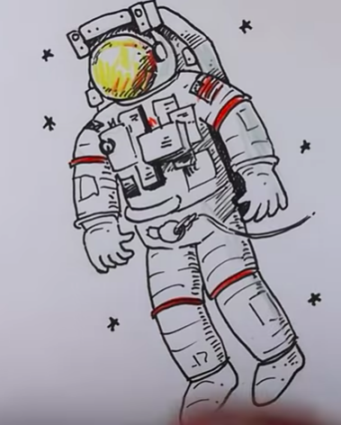  *If you’d rather draw something else, that’s fine too!*  Please post your drawing into your Hand In Folder

