In 20 Years, we’ll all live in Canada!

Climate change is coming.

Lizzy Francis, Fatherly.com - September 16, 2020

Well, this is depressing. New data assembled into an interactive map by the Rhodium Group has shown that by 2040, climates, warming temperatures, changing rainfall patterns, and more will drive populations, and agriculture, northward, while also warning that rising sea levels will drown coastlines — and that for many days of the year, entire regions across the country could become far more uninhabitable due to the level of heat. One county in Arizona is expected to have temperatures above 95 degrees for over half of the year.
In the United States, much of the country — from the east coast through North Texas up to Nebraska and all the way to California — has long existed in what scientists refer to as the human climate “niche,” per ProPublica. A human climate niche is an area where temperature and precipitation is suitable for human life. Based on this data, and on current climate projections that show how much the planet will warm over the next decades, even under moderate emissions scenarios, by 2070, much of the Southeast will become far less suitable for human life, making the midwest far more hospitable.
By 2040 to 2060, ProPublica reports, extreme temperatures will become the norm in the South and Southwest. But it’s not just heat that will drive Americans out of their homes: humidity and rainfall patterns will also make it difficult for the human body to control its own temperature for one out of every 20 days of the year in the Midwest and Louisiana by 2050. Farm productivity, of course, will also be exacerbated by this — much of the agricultural industry will be obsolete by then.

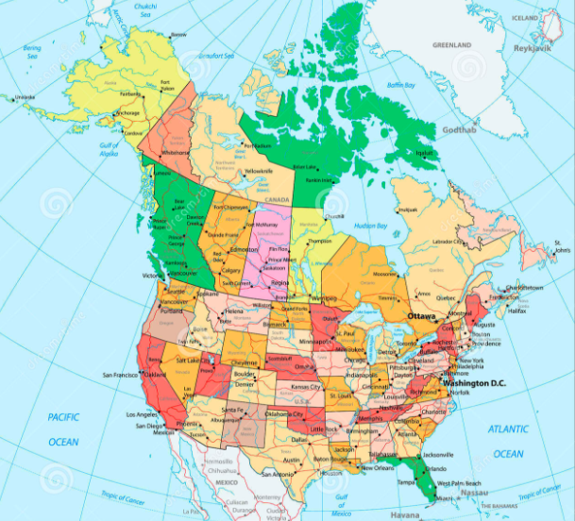
Wildfires will become more frequent, more intense, and move East across the country from California; 50 million Americans who live in eight of the largest U.S. metro areas will be affected by properties being submerged by rising sea levels; it will become difficult to grow food, the economic toll of climate change will be catastrophic, and some areas in the United States will see a number of problems compound on one another. That means that not only will heat effectively make Pinal County, Arizona, far less liveable, humidity, affected farm crop yields, large fires, and economic damages will all compound on one another to catastrophe. Climate change, it appears, is coming for us all. If we don’t take drastic action to mitigate its effects, the planet could become uninhabitable.

