A Canadian Hero - The Terry Fox Story (from terryfox.org)
Terry Stanley Fox was born July 28, 1958, in Winnipeg, Manitoba and was named after uncles on both sides of the family. He had an older brother Fred and a younger brother and sister, Darrell and Judith.
Early pictures show Terry as a serious child, wearing a white shirt and bow tie in one photo, a cowboy shirt with fringed trousers in another. Even as a child, the qualities that would bring him success in later life were in place. He was determined and tenacious.
Terry’s mother Betty recalled that as a toddler he stacked wooden blocks tirelessly. If they tumbled down, he’d try again and again until they stayed in place. Terry developed patience, too. As a child he loved games that lasted a long time. Luckily, he enjoyed his own company because few children had his perseverance even in play. He could amuse himself for hours. Sometimes he set up a table-hockey game and devised a long, complicated season’s schedule. He would play for both teams, allowing three passes before he would switch sides and shoot for the other team. He continued playing long after his interest in working the players had waned, he said, because he wanted to see who won. Terry loved playing with toy soldiers, too. He would bundle up carpets and make fortresses of them in the basement, arranging his armies of cowboys and Indians or soldiers from both world wars on either side. When the soldiers lay face down, they were dead; face up, they were wounded. He fought to the last man.
The boys all loved sports, whether it was road hockey or baseball, and they all liked to win, no matter what they were playing. Sometimes Terry and Fred would gang up on their father Rolly as he lay on the chesterfield. They would pummel him, and he’d fight them both. Each one did his best to get in the last punch, although Fred and Terry would usually be in tears before the rough housing was over. “We really fought dirty,” Terry remembered. “We’d be bawling our eyes out but we’d come back for more. Even to get one more shot in was worth it.”
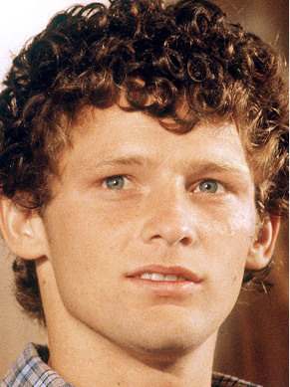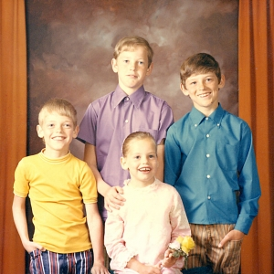
Betty and Rolly insisted on good behaviour and respect for older people. Well into adulthood, the Fox children would continue to address family friends as Mr., Mrs., or Miss. They changed their clothes after school before going out to play. Good table manners were important too: use your knife and fork, keep elbows off the table, no hats at the table.
They were expected to stay out of trouble, and if they got a job, they were to keep it. The children started berry-picking when they were nine or ten years old and continued at these seasonal jobs when they were teenagers. By twelve or thirteen, they were buying their own school clothes and later would buy their own golf clubs and ten-speed bikes. “Everything wasn’t handed to them, they all had to learn to do for themselves,” Betty said. The children didn’t have paper routes because she said it wasn’t fair to make them get up at 5:00 am. They needed rest and they needed time to play.

Terry was enthusiastic about sports and worked hard in every game.
In elementary school, he played baseball. Sometimes he’d arrive an hour early at the corner where he was to pick up his ride, just to make sure he’d get to the park on time. When they were in grade eight, Bob McGill, the physical-education teacher at Mary Hill Junior High School, noticed two young players: Terry and his friend Doug Alward. Terry was “the little guy who worked his rear off. If there was a race, he’d be in the middle of the pack. In class, he’d be sitting three-quarters of the way back, so small that in the big junior-high desks his feet wouldn’t touch the floor. His head would be lowered, and if a teacher was looking for answers to questions, Terry would be saying to himself, ‘Oh, God, please don’t let him ask me, please. If he does, I’ll just die.’ And if a girl happened to look his way, he’d just shy away.” Doug was much the same. He and Terry had at least three things in common in grade eight: both were introverts, both stood five feet tall, and both were crazy for basketball. Doug, who was also a talented cross-country runner, was a first-string basketball player; Terry, however, was terrible at the game, even by the standards of the Mary Hill Cobras. McGill suggested Terry try out for cross-country running. He might as well have asked Terry to skydive. The boy had no interest in running, but Terry started training anyway, because he had so much respect for the coach and wanted to please him. He found the workouts exhausting, and was often afraid to start the runs because they were so demanding. The biggest reward came at the end, when the coach would welcome the runners in, and say, “Well done, men.” That’s what Terry remembered: his teacher congratulating the skinny boys by calling them men.
Terry still wanted to play basketball. After three basketball practices, McGill suggested that he might be better suited for wrestling. There were other small boys who showed more ability than Terry as guards. But Terry was determined to stick with the game, even if he was the nineteenth player on a team of nineteen. He worked hard in practice and was rewarded with one minute of floor play all season. He thought his teammates laughed at him for that, but he didn’t let it get him down.
That summer he called Doug and said, “Do you want to play a little one-on-one?” Doug, at the other end of the line, paused, remembering that Terry was a pretty fair runner, but a lousy basketball player, and said no. But Terry persisted. The second time he called, Doug agreed. “I could probably beat him twenty-one to nothing, but I don’t remember if I ever did. He might get ten points off me,” Doug said, “but the point was he couldn’t beat me.” The two boys played hard all summer. Doug’s older brother Jack, who was a gifted high-school basketball player, often joined them. By grade nine, there were four boys pounding the floor of the Mary Hill gym every morning before school. Doug wasn’t one of them, but Terry was.
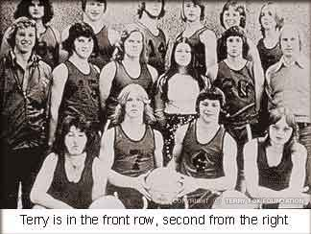
“Mom and Dad didn’t like me getting up early to go to school to play basketball,” Terry recalled. “Because they didn’t want me to go early, I’d wait until the very last minute to get out of bed. I’d eat my breakfast as fast as I could, and I’d run all the way — and Mary Hill was far from our house. I’d run in the dark with all my books and clothes flying.”
He remembered days when he felt sick with flu or a cold, when he should have stayed in bed, but he forced himself to his feet and ran to school anyway. He didn’t want to fall behind in his classwork, but most of all he didn’t want to miss a moment of basketball. Bob McGill had that effect on all the boys on the team. When he said, “If you want something, you work for it, because I’m not interested in mediocrity,” Terry and the others listened. McGill told them they could be the best, but only if they got up early, practiced before school, and stayed late afterwards. He didn’t call him Mr. McGill as the other boys did. He called him Coach, and said it with respect. McGill’s policy was not to cut anyone from the team, but he let the boys know that only the twelve best players would be allowed floor time. In grade nine, Terry was one of the twelve best. He wanted to be as good as the coach believed he could be. “He was such an inspirational person, I wanted to show him that I was a lot better than being laughed at by the other players,” Terry recalled. McGill chuckled with pride, remembering the way he pushed and encouraged the team, and the way Terry, in particular, responded: “If I had told Terry to hit his head against the wall, he would have,” McGill said, “because that’s how much he believed in what I was trying to do.”
By grade ten, Terry had earned a place on the team as a starting guard. His pal Doug was a co-winner of the Athlete of the Year Award at Mary Hill. They’d both earned respect. McGill remembered Doug and Terry as starting guards in a game against the team with the tallest players in the league. When the Johnston Heights boys lined up against the Mary Hill boys, they just started laughing. Doug and Terry were now both five-foot-six, but the boys they had to check seemed like giants. There’s no question which team won, but at the end of the game, the two Johnston Heights guards came over to shake hands with Doug and Terry. They knew they’d been in a game.
In grade eleven, when Terry joined the Port Coquitlam High School Ravens basketball team, he was a starting guard. Doug, who had taken a term at Centennial High School because it offered a better athletic program, remembered Terry once scored twenty points in the first half of a game. “All of a sudden, he’d become somebody by working hard,” Doug said. Even when the team was being clobbered, the basketball coach, Terri Fleming, recalled that Terry never gave up.
By 1976, the one-on-one games between Terry and Doug were repeated, but with a twist: Terry could now beat Doug twenty-one to nothing. Except once. Doug recalled: “Terry was taller than me in grade twelve, and I remember playing with him in practice. I faked him out and, to my horror, I scored on him. I couldn’t believe I had scored. He was mad, and the reason he was mad was that he had let down. He had thought, ‘Ah, Alward, I can stuff him,’ but I had faked him out. He picked up the basketball and slammed it down hard on the floor. The other guys in the line-up just looked on in stunned silence.”
Terry shared the Athlete of the Year Award with Doug in grade twelve. Doug had become an accomplished runner and came second in the British Columbia cross-country finals. He always liked to deflect attention from himself, saying that Terry deserved the award more than he did because Terry was a better basketball player, a first-class soccer player, and a gutsy rugby player. Doug recalled one rugby game in particular: “This big guy got by everybody, and Terry was the last guy to stop him. Terry got him with this fantastic tackle. Man, he was tough! I could feel it from the sidelines. Holy cow, he should have had pads on. He may have been scared, but he’d stand there and face it.” Later, when Doug won a $2,000 Nancy Greene Scholarship to university, he wrote a cheque for that amount and sent it to Terry with a note saying Terry was a better athlete and more deserving of the award. Terry returned the cheque, but no one forgot Doug’s kindness.
Although Terry remembers being an average student at Mary Hill, the truth is he and Doug made it to the honour roll a few times. Both had a fondness for biology. That science was made for them because it required lots of memorization. The two hard-driving athletes, who were by this time used to putting in long hours in training, applied the same discipline to memorizing a hundred pages of biology notes.
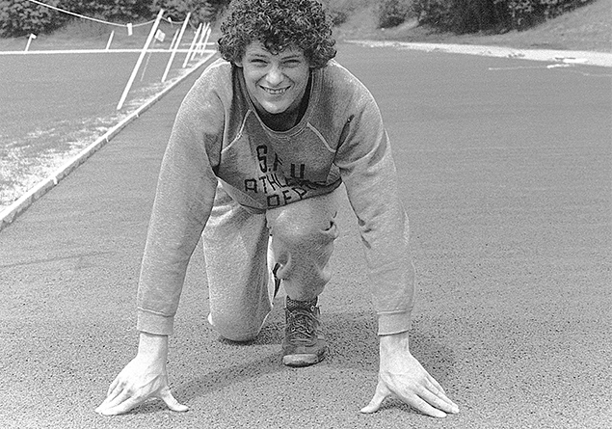
The competitive spirit they shared in sports was also apparent in their academic work. Doug, who seems to have been the sly one, turned to subterfuge to set Terry up again. This time his ploy was to tell Terry that he was not going to open a book to study for their next exam, but secretly, at home on the other side of town, Doug drove himself to desperation with study. When the exam results were posted, Terry was amazed to see that Doug had earned one of the top scores. Later, analyzing the outcomes, Doug thought he beat Terry — who, he believed, was more naturally gifted — because Terry let down his guard. In his mind the challenge was diminished. Why did Doug go through this exercise? “I wanted to beat him.” Terry worked and played in a competitive world.
Betty was annoyed when Terry belittled his academic abilities. She wasn’t a pushy mother, but she let him know she had high expectations of him. Terry remembered presenting his mother with his School report card and watching her carefully, wondering what she thought of his grades. Were they good enough? Was she proud of him? Was he doing well? “Sometimes, because I knew she cared, I’d do things for her,” he said. “Even in school I wanted to get good grades to show her I could do it.”
Terry’s interests and friendships broadened in high school, and he and Doug drifted apart. Terry spent more time with his basketball teammates. He went to parties with them, would have a few drinks, and remembered getting roaring drunk a couple of times. He even dated occasionally. “There were lots of girls I knew who liked me and wanted to go out with me, but I was still too shy,” he said. He didn’t have a steady girlfriend. He felt more at ease with his locker-room friends, and more than anything, he said, he enjoyed playing basketball. Terry wasn’t interested in the drug culture that left some in his generation dozing on the beaches. He never sampled marijuana, not even out of curiosity.
Judith saw her older brother as a complex person. He was obedient — that wanting-to-please part of his personality — but Terry gave all of himself in everything he tried, and he expected the same from others. They would fight, she said, when she wouldn’t do what her mother asked her to do. He was funny, too. He loved to joke around, wrestle, play hide-and seek. “There was this silliness, all the time. He was an incredible person. He knew how to be serious and get the job done, but also had a lot of fun.”
He graduated from Port Coquitlam High School with A’s and one B. Memorization and all the self-discipline in the world couldn’t get him through essay writing, the subtleties of Waiting for Godot, and other high school literature assignments.
While Terry wasn’t sure he wanted to go to university, Betty was sure that he should. He enrolled at Simon Fraser University in part to please her and in part for himself. He knew he wanted to play more basketball, though he realized that the competition at university, especially at SFU, which had the best varsity team in British Columbia, would be fierce. Naturally, that would attract rather than deter Terry. He was also thinking he might want to be a high-school physical education teacher. He liked the idea of being “the coach” to a bunch of skinny boys with more drive than talent. Since he enjoyed sports, he chose kinesiology, the study of human movement, as a major, although Betty would have preferred, he enroll in one of the professions. It didn’t surprise any of his former coaches or friends that Terry tried out for the SFU junior varsity team. The two-week training camp run by basketball coach Alex Devlin was tough, more of an endurance test than anything else. Devlin and the players, including Mike McNeill, who later became the head basketball coach at SFU, saw others who were more gifted than Terry, but none showed more desire. McNeill, a first-string guard on the varsity team, said: “In the summer after high school, we knew Terry was coming out for the team. I played against him offensively, and he wasn’t that good, but defensively, he was one of the toughest I’d ever played against. He had a lot of pride and he worked hard.” During the training camp, Devlin told Terry, “We’ve been noticing you.” His determination and hard work paid off. He made the team. “There were more talented players who didn’t make it,” McNeill recalled, “but Terry just out-gutted them. People tend to look in awe at players who have a lot of natural ability, but respect from other athletes goes to the guy who works really hard.” That was Terry.
Terry believed the key to his success was his mental toughness. He had learned that training in junior high school as a cross-country runner, in the long hours playing one-on-one, and on the rugby field where his opponents would happily trample him into the mud. He had also learned it at home, where the friendly fisticuffs on the couch were replaced by lively, sometimes stormy, always stubborn debates over cards, over who was the best player in the National Hockey League, over anything.
Terry liked to argue until his brother or father would give up, either from exhaustion or intimidation. In the Fox household, it seemed everybody shared that argumentative streak, the belief that you stick up for yourself, even if you are wrong. The habit of arguing reinforced his stubborn will.

Terry believed the key to his success was his mental toughness.

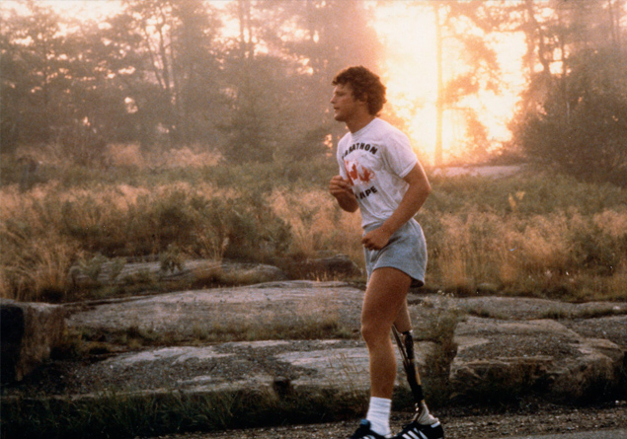

The Marathon of Hope. “It’s got to keep going without me”

September 1, 1980 – It was a dull day in Northern Ontario when Terry Fox ran his last miles.
He had started out strong that morning and felt confident. The road was lined with people shouting, “Don’t give up, you can make it!” words that spurred him and lifted his spirits. But after 18 miles he started coughing and felt a pain in his chest.
Terry knew how to cope with pain. He’d run through it as he always had before; he’d simply keep going until the pain went away.
For 3,339 miles, from St John’s, Newfoundland, Canada’s eastern most city on the shore of the Atlantic, he’d run through six provinces and now was two-thirds of the way home. He’d run close to a marathon a day, for 143 days. No mean achievement for an able-bodied runner, an extraordinary feat for an amputee.
Terry’s left leg was strong and muscular. His right was a mere stump fitted with an artificial limb made of fibreglass and steel. He’d lost the leg to cancer when he was 18.
He was 22 now; curly haired, good-looking, sunburned. He was strong, wilful and stubborn. His run, the Marathon of Hope, as he called it, a quixotic adventure across Canada that defied logic and common sense, was his way of repaying a debt.
Terry believed that he had won his fight against cancer, and he wanted to raise money, $1 million perhaps, to fight the disease. There was a second, possibly more important purpose to his marathon; a man is not less because he has lost a leg, indeed, he may be more. Certainly, he showed there were no limits to what an amputee could do.
He changed people’s attitude towards the disabled, and he showed that while cancer had claimed his leg, his spirit was unbreakable. His Marathon of Hope had started as an improbable dream – two friends, one to drive the van, one to run, a ribbon of highway, and the sturdy belief that they could perform a miracle.
He ran through ice storms and summer heat, against bitter winds of such velocity he couldn’t move, through fishing villages and Canada’s biggest cities. Though he shunned the notion himself, people were calling him a hero. He still saw himself as simple little Terry Fox, from Port Coquitlam, British Columbia, average in everything but determination.
But here, 18 miles from Thunder Bay, at the head of Lake Superior, the coughing had stopped, but the dull, blunt pain had not. Neither running nor resting could make it go away. He saw the people lined up the hill ahead of him. The Ontario Provincial Police cruiser was behind him, red lights flashing in the drizzle, and cheers still surrounded him: “You can make it all the way!
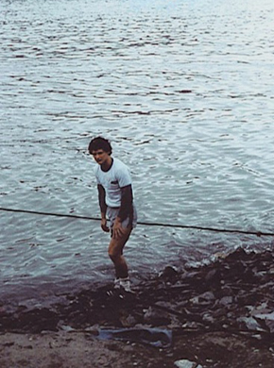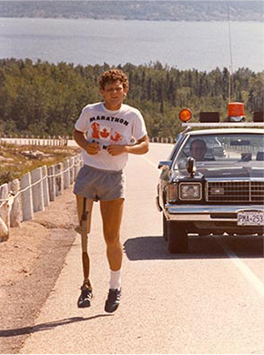
Terry could not ignore what people said to him. He listened. “I started to think about those comments. I thought this might be my last mile.” He ran until there were no more people, and then he climbed wearily into the van and asked his friend and driver Doug Alward to drive him to a hospital.
When Terry won a place on the junior varsity basketball team at Simon Fraser University in 1976, many were surprised. He was not a gifted player. Others were more talented, though few could match him for determination, toughness, and hard work.
It had always been that way. When he was in Grade 8, Terry was rated 19 on a team of 19 players and was on the court for only one minute that first season. That didn’t deter him. Two years later he was a starting player. By the time he graduated from high school, he and his friend Doug were named athletes of the year.
Aches are common in an athlete’s life, but at the end of his first year of university, there was a new, alarming pain in his knee. One morning he woke to find he couldn’t stand. A week later, he learned this was no cartilage problem, as he had thought. He had a malignant tumor; his leg would be amputated in four days. His doctors told him bluntly, because of recent advances in research his chances of survival were 50 to 70 per cent. If he’d become sick two years earlier, his chances would have been 15 per cent.
The night before his operation, his high school basketball coach, Terri Fleming, brought him a running magazine which featured an article about an amputee, Dick Traum, who had run in the New York City Marathon. And though his future was never more precarious, Terry dreamed that night about running across Canada. “I’m competitive,” Terry said. “I’m a dreamer. I like challenges. I don’t give up. When I decided to do it, I knew I was going to go all out. There was no in-between.”
The 16 months of follow-up treatment marked Terry irreversibly. He saw suffering as he’d never seen it before. He heard doctors telling youngsters in the nearby beds that they had a 15 per cent chance of living. He heard screams of pain. He saw strong, young bodies wasted by disease. He never forgot what he’d seen and when he left the cancer clinic for the last time, he left with a burden of responsibility. He was among the lucky one-third of patients who survived.
“I could not leave knowing these faces and feelings would still exist even though I would be set free from mine,” he wrote in a letter asking for sponsorship for his run. “Somewhere, the hurting must stop… and I was determined to take myself to the limit for those causes.

“Somewhere, the hurting must stop... and I was determined to take myself to the limit for those causes.”

TERRY FOX - OCTOBER 1979

It was Rick Hansen who invited Terry to get back into sports and join a wheelchair basketball team. (Rick and Terry were of the same mold; later Rick, a paraplegic, would push his wheelchair around the world, and he never failed to give credit to Terry, the friend who inspired him.)
Terry tackled this new challenge with his usual gusto. He made himself strong pushing his wheelchair along the sea wall at Stanley Park in Vancouver. Or he’d find steep mountains and push himself up unruly logging roads. He pushed himself until his hands bled.
Two years after his operation, Terry started a running program. The first half miles he ran in the dark, so no one could see him. But one of his coaches from junior high, Bob McGill, who had since overcome cancer himself, heard the steady one-two thump of Terry’s good leg and the thud of his artificial leg, long before he could see his wobbly frame in the darkness.
Terry trained for 15 months, running 3,159 miles, running until his stump was raw and bleeding, running every day for 101 days, until he could run 23 miles a day. He took one day off at Christmas, only because his mother asked him. Once, just before Christmas, when he had run only a half mile, the bottom half of his artificial leg snapped in two pieces, and Terry crashed to the pavement. He picked up the two parts, tucked them under his arm, stuck out his thumb and hitch-hiked home. There, he clamped the two parts together and ran another five miles.
When Terry told his mother Betty, he intended to run across Canada, in her no-nonsense way she told him he was crazy. He said he was going to run no matter what she thought. Then Betty told her husband Rolly, and he, knowing his son so well, simply said, “When?”
When Terry approached the Canadian Cancer Society about his run, its administrators were skeptical about his success. They doubted he could raise $1 million and as a test of his sincerity, told him to earn some seed money and find some corporate sponsors. They believed they’d never hear from him again.
But Terry persevered, earning sponsors and the promise of promotion from the cancer society. On April 12, 1980, he dipped his artificial leg in the murky waters of St John’s harbour and set off on the greatest adventure of his life.
“I loved it,” Terry said. “I enjoyed myself so much and that was what other people couldn’t realize. They thought I was going through a nightmare running all day long. “People thought I was going through hell. Maybe I was partly, but still I was doing what I wanted and a dream was coming true and that, above everything else, made it all worthwhile to me. Even though it was so difficult, there was not another thing in the world I would have rather been doing. “I got satisfaction out of doing things that were difficult. It was an incredible feeling. The pain was there, but the pain didn’t matter. But that’s all a lot of people could see; they couldn’t see the good that I was getting out of it myself.” And the people of Canada were latching on to Terry’s dream. They wept as he ran by, fists clenched, eyes focussed on the road ahead, his awkward double-step and hop sounding down the highway, the set of his jaw, unflinching, without compromise. The look of courage. As a woman in Toronto, Canada’s largest city said, “He makes you believe in the human race again.”
He’d start before dawn every morning, running in shorts and a T-shirt printed with a map of Canada. He wasn’t ashamed of his disability. Children were curious about his artificial leg. How did it work? What happens when it breaks?
Donations poured in. Reading of Terry’s goals, Four Seasons’ President, Isadore Sharp, was also caught up in the dream of the Marathon of Hope. He pledged $10,000 to the marathon and challenged 999 other Canadian corporations to do the same.
If $1 million toward cancer research was within reach, why not $1 from every Canadian; why not a goal of $23 million? The money came in many ways. People waited for hours on the roadside to watch Terry pass. Sometimes a stranger would press a $100 bill into his hand as he ran by.
One day in southern Ontario, they collected $20,000 on the highway. A man in Hamilton sat in a vat of banana lemon custard and raised $912 for the Marathon of Hope. In Gravenhurst, the heart of Ontario’s cottage country, with a population of 8,000, they raised more than $14,000. A musician, apparently without cash, handed Terry his $500 guitar.

Throughout his run and even in the months before, Terry neglected his medical appointments. No one could force him to see a doctor for a check-up. He said he didn’t believe the cancer would come back. Earlier, when he’d missed his appointments for x-rays at the cancer clinic in Vancouver he said, “Every time I went down, I was shivering and it wasn’t because I was cold. I was afraid.”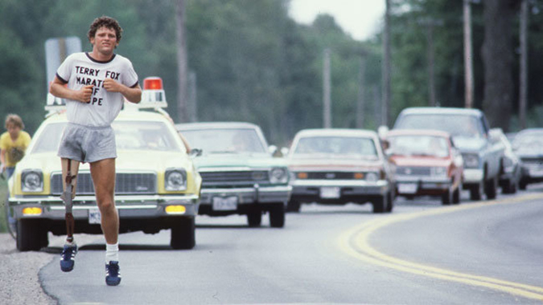
Doctors in Thunder Bay confirmed that cancer had spread from his legs to his lungs. He phoned his parents who caught the first plane to Thunder Bay. Terry was so weak when he tried to walk across the street to a car so they could get a bite to eat outside the hospital, he collapsed. “The day before I’d run 26 miles and now I couldn’t even walk across the street,” he said.
Betty wept; Rolly’s mouth was taut and hard as Terry spoke to reporters: “Well, you know, I had primary cancer in my knee three and a half years ago, and now the cancer is in my lung and I have to go home.” His voice broke as he spoke. He continued softly, “and have some more x-rays or maybe an operation that will involve opening up my chest or more drugs. I’ll do everything I can. I’m gonna do my very best. I’ll fight. I promise I won’t give up.”
His father, Rolly, was overheard to say, “I think it’s unfair. Very unfair.”
“I don’t feel this is unfair,” Terry told him. “That’s the thing about cancer. I’m not the only one. It happens all the time, to other people. I’m not special. This just intensifies what I did. It gives it more meaning. It’ll inspire more people. I could have sat on my rear end, I could have forgotten what I’d seen in the hospital, but I didn’t.”

“How many people do something they really believe in? I just wish people would realize that anything’s possible, if you try; dreams are made, if people try. When I started this run, I said that if we all gave one dollar, we’d have $22 million for cancer research, and I don’t care man, there’s no reason that isn’t possible. No reason. I’d like to see everybody go kind of wild, inspired with the fund-raising.”
He came home in a private jet. This was not the triumphant homecoming he and so many others had imagined. The run didn’t end with Terry dipping his artificial leg in the seawaters off Vancouver’s Stanley Park; instead, he was taken by ambulance back to the Royal Columbian Hospital.
He continued to wear his Marathon of Hope T-shirt in hospital and refused the many offers, including one from the Toronto Maple Leaf hockey team, to finish his run for him.
In less than 48 hours the CTV television network arranged a special telethon and by the end had raised more than $10 million – $1 million from the provincial government of British Columbia, another $1 million from the province of Ontario and substantial cheques from corporations. Most, however, came from private donations.
Isadore Sharp had sent a telegram which Terry pinned to his hospital bed. He said that Terry’s marathon was just the beginning and that a fundraising run would be held in his name every year to continue his fight against cancer.
“You started it. We will not rest until your dream to find a cure for cancer is realized.”
For the next 10 months, Terry battled the disease. Some days the pain was nightmarish; some days, he felt well enough to go out with Rick Hansen and his friends.
As he fought for his life, he was honoured with awards: He was the youngest Companion of the Order of Canada, the nation’s top civilian honour; he was named Newsmaker of the Year by the Canadian Press; he won the Lou Marsh trophy for outstanding athletic achievement; his portrait was hung in the Sports Hall of Fame and letters of encouragement came from around the world; and, most importantly, donations to his Marathon of Hope reached $23.4 million. The Guinness Book of Records named him top fundraiser. A mountain was named after him in British Columbia.
Terry died, his family beside him, June 28, 1981 – one month short of his twenty-third birthday.
There was nation-wide mourning. Flags were flown at half-mast. But people didn’t forget him and his story didn’t end with his death. The first Terry Fox Run was held that September – more than 300,000 people walked or ran or cycled in his memory and raised $3.5 million.
Terry’s mother Betty says there would be no Terry Fox Run if not for Isadore Sharp. And Mr Sharp, who has known the loss of a son to cancer, believes one day a brilliant young researcher, perhaps one funded by a Terry Fox grant, will find a cure for the disease.
“Terry did not lose his fight,” Mr Sharp says. “Perhaps he finished all he had to do. Terry is like a meteor passing in the sky, one whose light travels beyond our view, yet still shines in the darkest night.”
