Ancient China Movie Trailer Project

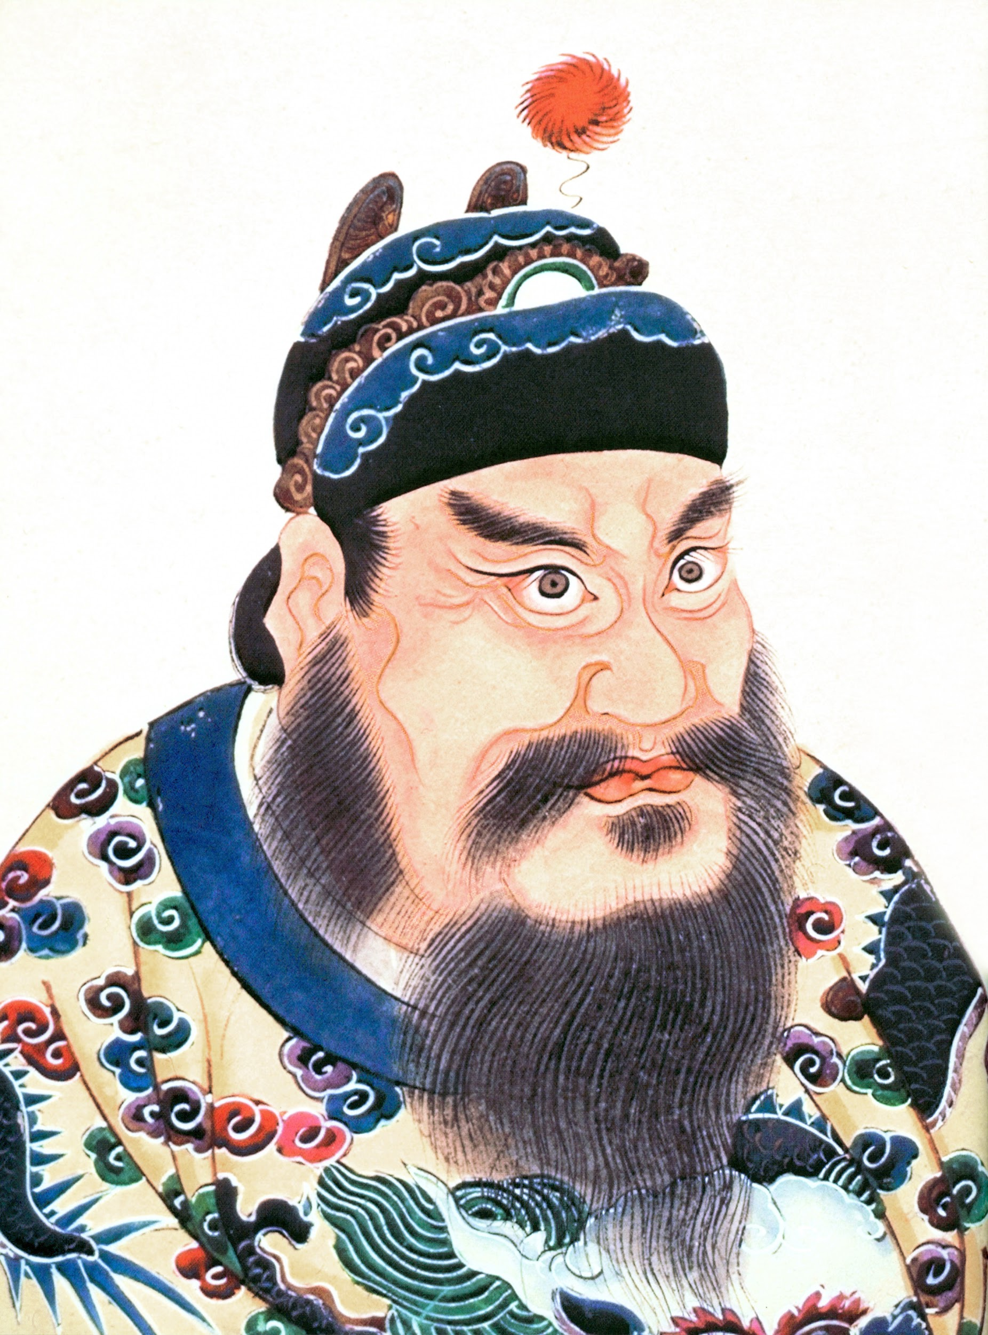
Lights, Camera, Action! You will be creating a movie trailer (using iMovie) to tell the class about a certain aspect of Ancient Chinese History. This will be part of our first foray into our Digital Arts and Humanities units. Luckily for you, the topic is broad, but to help narrow it down, your trailer MUST relate to an aspect of Ancient Chinese Civilization.

Here are your choices:

1- culture,
2 - history,
3 - significant person,
4 - significant event.

Your movie trailer will need to follow the suggested filming format, and must be between 1 - 2 minutes.

You will need to choose from one of the existing iMovie trailer themes and their music. (You will get to choose your own style and music in another larger project later in the year.)

Here’s what you will need:

A script / storyboard - explains what you will do, which graphics you will use, and includes and any props / costumes necessary

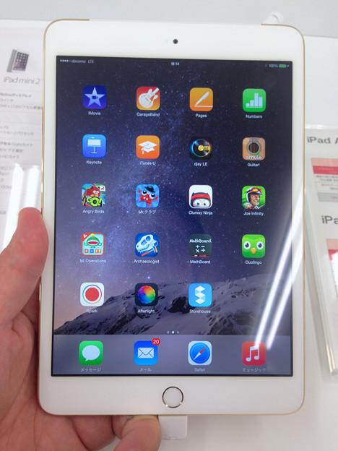
An iPad - to record your work. 