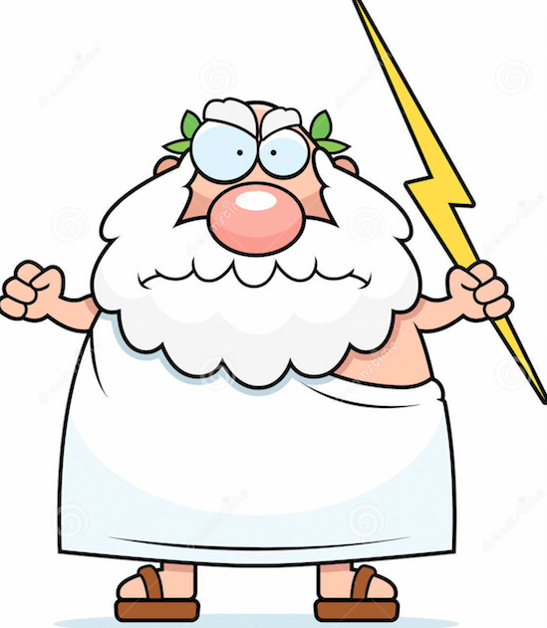
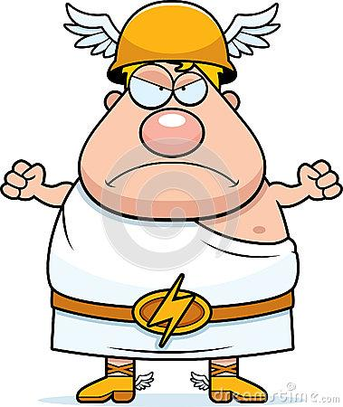
Ancient Greek Myth Video:
Integrated Social Studies, Language Arts and Digital Arts project.

For this project, you will be combining the skills you learned in photography and video making, with the information and details you’ve learned in both Social Studies and Language Arts.

**This is a group project, and all groups should have a minimum of 3 members.**

Please use this outline to guide you through the organization, research and planning process of your video, and be sure to include all of the criteria listed to ensure you complete your project on time and within the guidelines of the assignment.

Challenge: Research, Write and Create a 5 - 6 minute video that retells an Ancient Greek Myth.

Group Responsibilities:
- Research and write an original screenplay based on an Ancient Greek Myth. (Language Arts / Social Studies)
- Confer, plan & create a storyboard, as well as a list of props & materials. (Digital Arts)
- Record, edit and present a finished video project by the assigned deadline. (SS, LA & Dig Arts)

Deadlines: (use this to keep on track and organized)
- Greek Myth and Groups finalized (Monday, April 11th)
- Rough Copy of the Screenplay (Tuesday, April 19th) *must be typed, printed and submitted by 2:45pm*
- Storyboard and list of props & materials (Friday, April 22nd) *Must be submitted by the end of block 2*
- Final copy of Screenplay & Storyboard (Wednesday, April 27th) *Must be submitted by the end of block 2*
- Video edited and submitted (Wednesday, May 4th) *Must be submitted by the end of block 2*
- Viewing party!! (Friday, May 6th) *Drinks & Popcorn will be provided!!*

Rubric: Use the rubric to see how to meet the project expectations

Skill | Exceeding Expectations | Fully Meeting Expectations | Minimally Meeting Expectations | Not Yet Meeting Expectations
Following Instructions & Meeting Assigned Deadlines | All elements of the project are submitted correctly, and before the deadlines. | All elements of the project are submitted correctly and by the deadlines. | Most elements of the project are submitted correctly and before the deadlines. | All or most of the elements of the project are submitted after the assigned deadlines.
Written Work (Screenplay & research notes) | Spelling and grammar are accurate, and work is excellently researched and presented. | Spelling and grammar are mostly accurate, and work is well researched and presented. | Spelling and grammar have mistakes, and work is researched and presented acceptably. | Spelling and grammar require a lot of improvement, and work needs further research and proof-reading.
Organization, Participation and Use of Time. | All students were on task throughout, worked well as a group, and kept to the prescribed outline. | Students usually worked well together, used their time efficiently, and were able to complete most of the elements of the assignment on time. | Students were able to work together, and complete the assignment, though struggled with staying on task and completing the elements on time. | Students did not work well together, and failed to complete some or all portions of the assignment within the assigned time.
Video Presentation. | Video features information about the Myth, is well edited and shot, stays within the time limit, and is appropriate for a middle school audience. | Video features information about the Myth, is adequately edited and shot, stays within the time limit, and is appropriate for a middle school audience. | Video is about an ancient Greek Myth, is edited and shot decently, is close to being within the time limit, and is appropriate for a middle school audience. | Video has very little to do with the ancient Greek Myth, is poorly edited and shot, does not stay within the time limit, and demonstrates little effort or is inappropriate for a middle school audience.

