Getting started on your Weebly Website

Sign Up
Go to the top
Firstly, head over to Weebly.com. You can build and publish your site totally free, so there’s plenty of time to see if you enjoy using it.
To kick things off, click ‘Get Started’ – either in the top right or bottom left corner. Now type in your name, email, and new password. The Weebly ball is rolling.
Getting started with Weebly is easy, with two clear action buttons in sight
After clicking ‘Sign Up’, you’re taken to a page with one question and two options: ‘What kind of website would you like to create?’
Choose from ‘I just need a website’ or ‘I need a website with an online store,’ depending on your ecommerce ambitions. Don’t worry – this decision isn’t final, as you can add a store to your Weebly site any time you like.
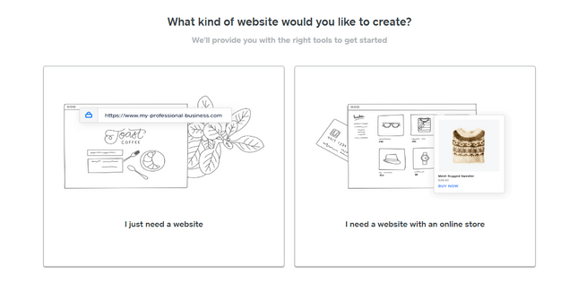
You can set up an online store anytime with Weebly, showing its flexibility
Weebly has a free plan which you can stay on for as long as you like. This is why you can create, publish, and edit your site without paying a single cent.
You can upgrade to a paid plan any time, but we’ll help you with that later – for now, just enjoy building your website!
Before moving on, make sure you have:
- Created a free Weebly account
- Chosen the type of website you want to create for now

Ready to Get Started?
Creating a website with Weebly is free, quick, and easy – visit Weebly to begin building!
Yes! Take Me to Weebly
Go to the top
2

Select a Theme
Go to the top
Weebly has around 50 themes, all of which are totally free! There are plenty of categories to choose from: ‘Business,’ ‘Portfolio’, ‘Personal’, ‘Blog’, and more. From your choice, Weebly then suggests some more specific themes.
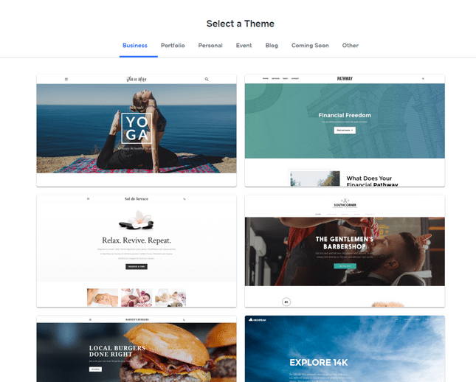Weebly has a wide choice of mobile responsive themes, for almost any industry
The Weebly themes are modern, sleek, and all mobile responsive. This means they look awesome on any screen. And, unlike Wix, you can change templates at any time, so you’re not restricted by your choice.
Can’t decide? You can preview each one by clicking the thumbnail to see how it looks on a full screen. Then, if you like it, hit ‘Start Editing’ in the top right. Make sure you click around for your favorite theme.
Weebly also offers industry-specific options. It has delicious restaurant templates, fresh cleaning service designs, strong-looking personal training themes – you get the idea. These options save you even more design time – you just need to edit the text boxes and images and you’re good to go.
The template is what your visitors see first, so make sure it says what you want it to. Do you want a clear CTA (Call To Action) button, like ‘Book Now’? Or would a series of images work better? Whichever you choose, there’s a Weebly theme to suit.
Weebly’s travel industry-specific templates come with well-placed action buttons
Before you move on, make sure you have:
- Browsed Weebly’s themes
- Previewed your favorite designs
- Picked your perfect theme

Want to See More?
Weebly has around 50 themes, and they’re all free! Weebly’s got something for everyone.
Pick My Perfect Weebly Theme
Go to the top
3

Choose Your Domain
Go to the top
Before you start editing, you’ll need to name your website. The name of your website appears in your website address and is called a domain name. For example, ours is websitebuilderexpert.com!
So, how do you go about getting a domain for your Weebly website?
It’s easy – Weebly will automatically prompt you to type in a domain name!
You can get a free domain by choosing the Weebly subdomain. This means your website address will contain ‘.weebly.com’ – it’s not very attractive or professional, but it means you don’t have to pay a cent for your domain.
See the image below for an example of a Weebly subdomain as well as professional, or custom, domains.
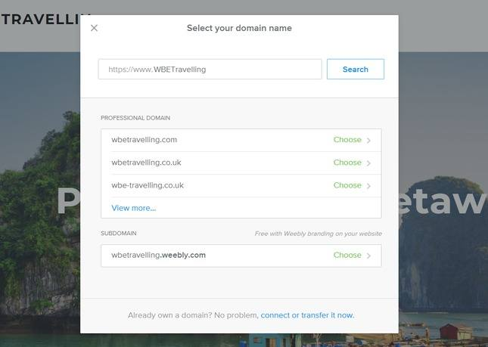Weebly offers a free subdomain name, ideal for cost-conscious users
If you want a custom domain (like ours), you can simply register one through Weebly. Just click ‘Choose’ to register your favorite domain. You will have to pay for this, however, and upgrade to a paid plan to actually use your domain.
The upside of using a custom domain is that it’s more professional, memorable, and attractive. Your domain is unique – think of it like your site’s fingerprint – so it’s worth finding the perfect one.
Just how much is a custom domain, though? Is it worth it?
Domains vary in price, but usually fall between $14 and $20 per year. Weebly’s domain prices fall into three options:
- 1 Year ($19.95)
- 2 Years ($16.95/yr)
- 5 Years ($14.96/yr)
Weebly offers discounted domain names, saving you dollars down the line
There are cheaper prices elsewhere (check out Domain.com for great deals – you can get 25% off using the code WBE25), but registering your domain through Weebly is the easiest and quickest option.
Already have a domain? You can easily connect it by clicking ‘connect or transfer now’ at the bottom of the popup – then just type in your URL and press ‘Search’.
No guide on building a website would be complete without some tips on how to create the best domain! So, here are our top tips – for a great domain, we recommend that you:
- Keep the name short
- Include popular keywords
- Target your area
- Make it memorable
And voilà! You have a beautiful domain just waiting to be used – let’s get on with building your site so you can make good use of it.
Before you move on, make sure you have:
- Decided if you want a free or custom domain
- Created your ideal domain name
- Registered your domain, either by paying or simply clicking ‘Done’

Further Information
- Want to know more about domain names? Our Domain Name Beginner’s Guide tells you everything you need to know.
Go to the top

4

Design Your Weebly Website
Go to the top
After choosing your domain name, you’re taken to the Weebly website builder screen. This is where you’ll let your creative juices flow. We’ll go through the menus and features one by one, but here’s what it looks like at first glance:
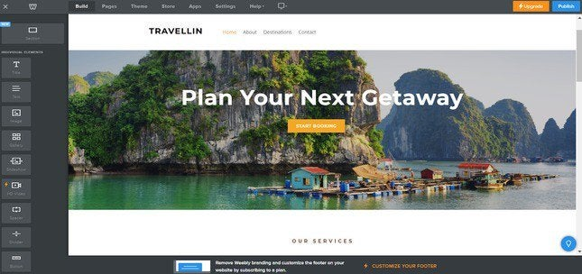
The Weebly editing homepage is easy to navigate and use

Editing Text Boxes
Weebly is a ‘What You See Is What You Get’ (WYSIWYG) website builder. This means you can click and edit, as well as drag and drop media, without needing to know any code. So to update the text, simply click the box and type.
Editing text boxes takes just a couple of clicks with Weebly

Editing the Background
You can customize your theme even more by changing the background. Simply click the background image and select ‘Edit Background’. From there you can change the image, scrolling effect, and page alignments.

Adding Elements
This is where you add the fun stuff. Using the ‘Element Menu’, on the left hand side, simply drag and drop your chosen media icon anywhere on the page. You can throw text, videos, buttons, and more anywhere you like. Take a look at the Element Bar below for just some of the elements you can choose from:
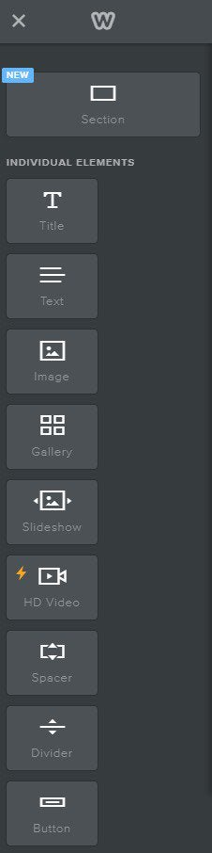The Weebly Elements Bar clearly shows what you can drag and drop onto your site
Any element with the lightning bolt symbol next to it can’t be used on the free plan – you’ll need to upgrade to use these features. However, everything else is free for you to play with!

Let’s say you want to add an image. Drag the icon where you want, then click ‘Upload Image’. A popup will then give you some options: you can upload from your computer, or press ‘Search’ and find a free Weebly image.
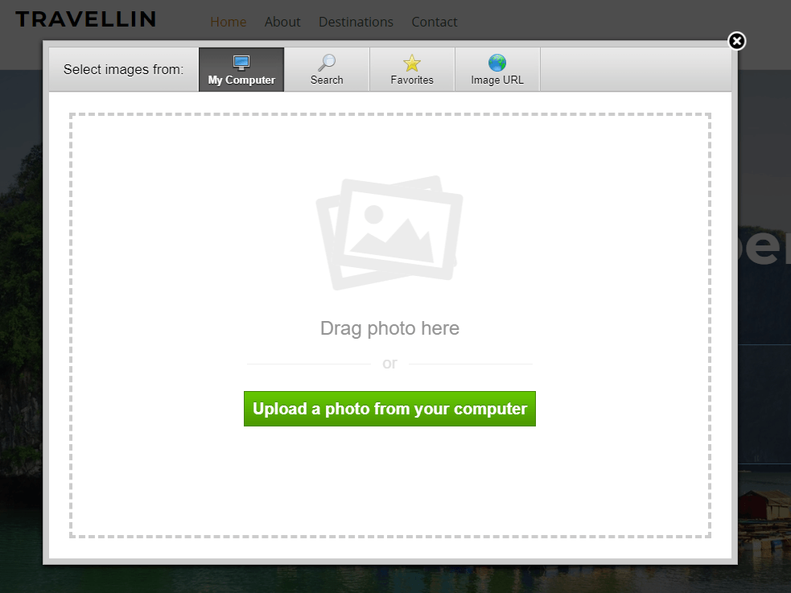Weebly provides a wide choice of free images to keep your design costs down
To edit other pages on your Weebly website, simply click ‘Pages’ on the top Navigation Menu and choose a different page. Adding elements is the same process for each page – just drag, drop, and click your way to a beautiful website.
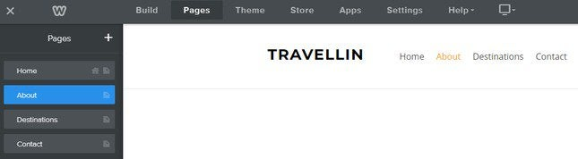Switching pages is a breeze with the Weebly navigation menu
From the Navigation Menu, you can make the most of Weebly’s flexibility. Change your theme, edit your site settings, move to a different page – it’s all there.
Check out our video below on how to use Weebly’s basic elements.
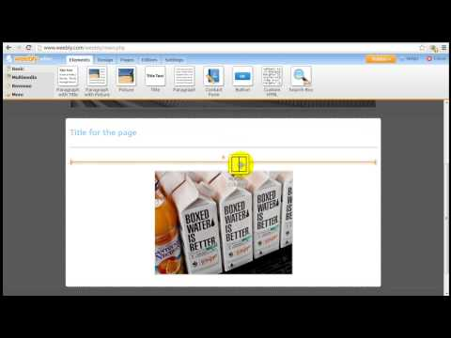Play

Adding New Pages
It’s easy to add new pages to your website. Simply go to the Pages tab in your menu and click the plus icon in the left-hand sidebar. A drop-down menu will appear with different types of pages.
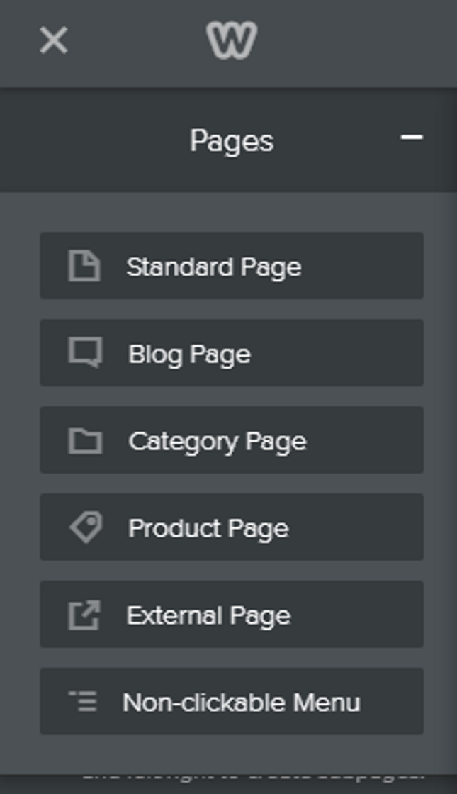
Weebly provides different types of pages you can create
Select the type of page you want to create – a blog page, for example – and give it a name. As you do this, Weebly automatically loads the page for you, with pre-filled images and content for you to make your own.
Remember to click ‘Done’ to save your new page’s settings. Once you’ve done this, return to the ‘Build’ menu tab to edit the page just like you would normally!

Changing the Color Scheme
You can change the color theme of your page by heading to the Theme section of your dashboard. For some themes you simply have the options of light or dark, while others give you actual colors to switch between.
This is fairly basic and you won’t see massive changes to your theme, but you can add a custom color to the range of choices if you want to.
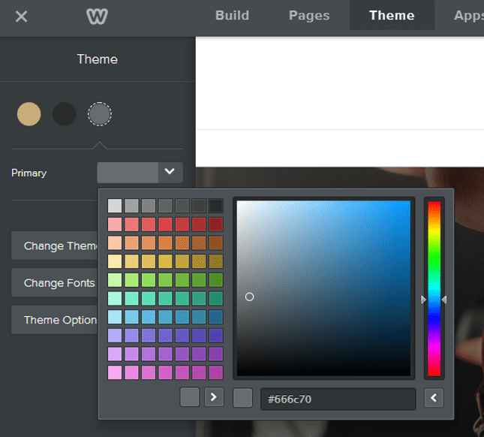
It's super easy to change your color scheme, although it's not a very advanced feature

Adding New Layouts
To really personalize your website, you’ll want to add new sections to the pages you’re editing. Apart from adding new elements, there’s also the option to add new sections.
This element sits at the top of the left-hand sidebar above all the other elements – simply drag it to where you want it on the page and let go.
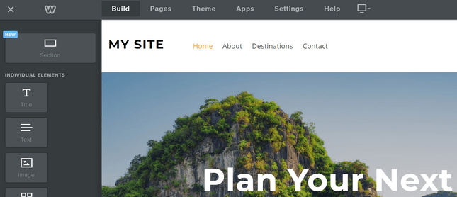
The Sections element sits above all the others in the left-hand sidebar
It’ll give you a list of options: Gallery, Contact, Menu, Featured, and Team. Select the one you want to add.
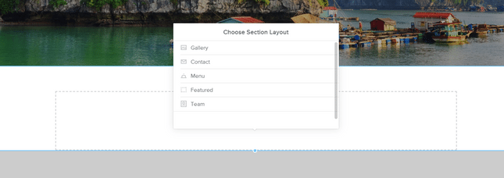
You can choose the type of section you want to add to your page
Weebly then gives you a list of different layouts to choose from, so you can pick the one you like the best. Click on the layout you want, and it’ll appear on your page. Click save in the popup box, and get editing!
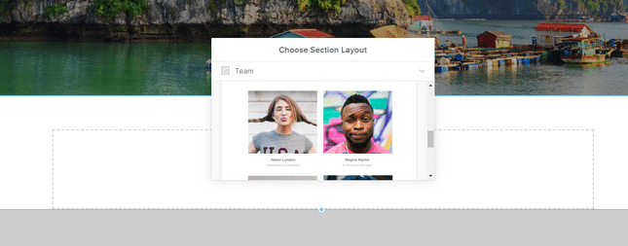
You can choose the layout of the section you want to add

Deleting Sections
We all make mistakes, we all change our minds, and we all learn differently – we’re only human after all! That’s why it’s important to know how to delete elements on your site, as well as adding them.
You might want to try out a gallery on your homepage, but then decide it doesn’t work. You’re not stuck with it forever – simply click on the element, and look for the small blue cross that appears in the top right corner of the editing box.
Click on that cross, the box will turn red, and you’ll have the option to delete that element.
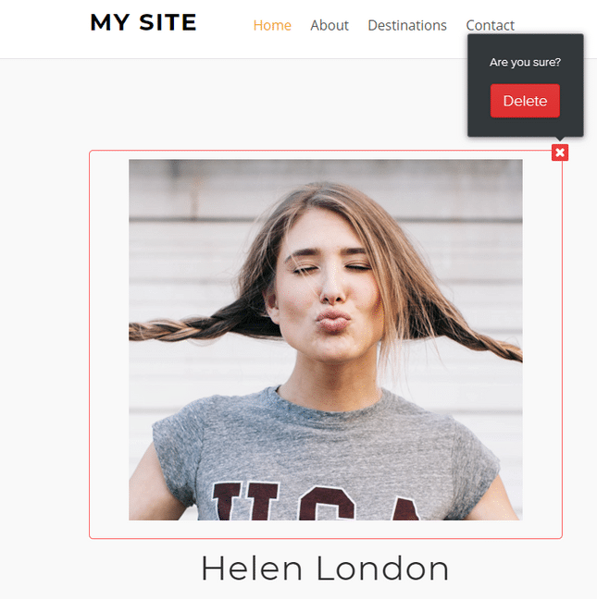
Deleting elements is easy - simply click the cross!
This is how to delete small elements such as galleries, text boxes, images, buttons, and more.
If you want to delete a larger section such as a background, simply click on the area you want to remove. You’ll see a few options appear: Edit, Move, and Delete. Click the Delete button and you’ll see a popup asking you if you’re sure you want to delete. At this point you can either cancel or confirm – if you click ‘Delete’ then that section and everything inside it will be deleted.
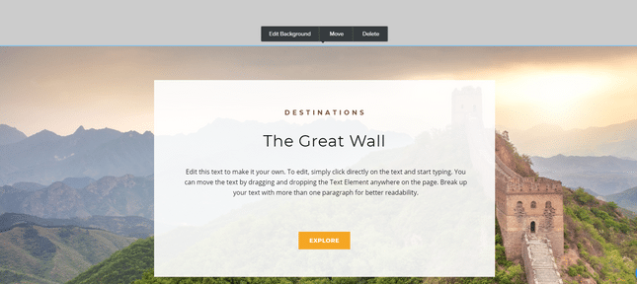
You can delete whole sections of your page if you want to - just click Delete and then confirm your decision!
This ‘are you sure?’ method means you won’t scrap any bits of your website by accident, which is a relief!
Before you move on, make sure you have:
- Edited text boxes
- Edited the background
- Added new elements
- Added new pages
- Experimented with your color scheme
- Added new layouts
- Checked you can delete unwanted elements
- Customized your Weebly site!

Are You Excited to Get Going?
Explore Weebly and get inspired to design your very own website. What will you create?
Take Me to Weebly!
Go to the top

