Weebly’s Customizable Backgrounds!
weebly.com
We’re incredibly excited to announce one of the most requested features of all-time, customizable background images! Upload any background image you want or select one from our new gallery of stunning (and free) stock images.
We’ve put together this quick introduction video to show you the new background editor in action. Have a look!
Change your background under Design > Change background. Doing this will add a whole new level of customization to your site, providing a unique, high quality feel that’s specific to your brand and site goals.
Note: Not every theme has a customizable background image. Use the “Supports background” checkbox under Design > Change Theme to filter to the themes that do.
There are seemingly endless possibilities in selecting your background image. Here are our top tips for choosing a background to best represent you:
1. Experiment with the blur, darkness, and filter options in the background editor to increase the contrast with your text and provide a more creative feel.
2. Choose an image that enhances, but does not compete with your overall design & content.
3. Try a few different background images to find the right look.
4. If uploading your own image, make sure the resolution is high enough so that it does not pixelate on large monitors, but try to stay under 1MB or else your site will load slowly.

Beautiful New Themes
To help you take full advantage of this feature, we’re launching 5 beautiful, new themes designed specifically to support background images. For a bit of fun and suspense, we will be releasing them individually over the next week!
Our designers drew inspiration from current trends as well as your most frequent requests in creating these fresh looks. We aimed to design aesthetically pleasing, modern themes with a focus on typography and a beautiful space for you to display your unique content.
Let’s get this theme party started with our newest theme, Lucent! As you can see, changing the background has a strong affect on the look and feel of the site.
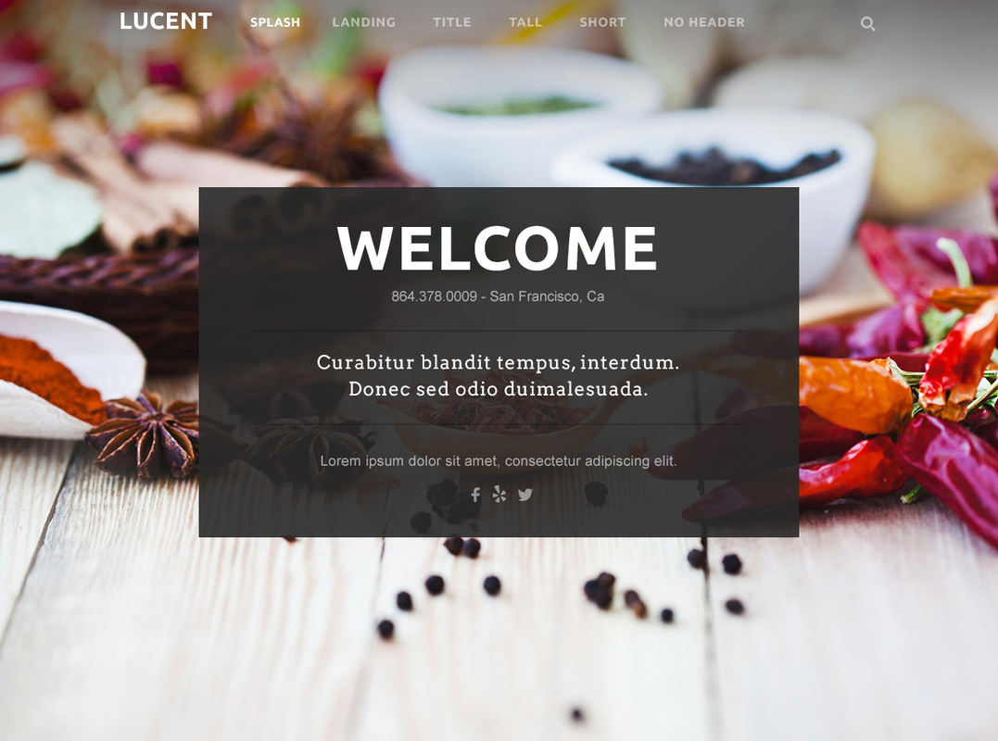
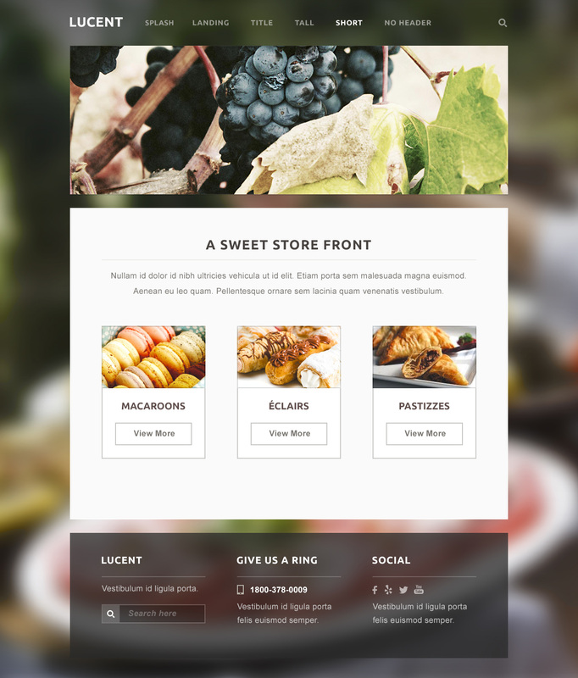
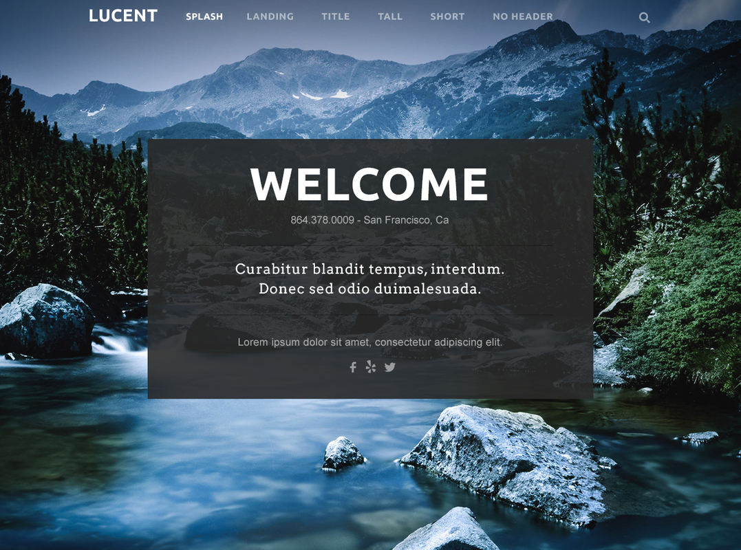
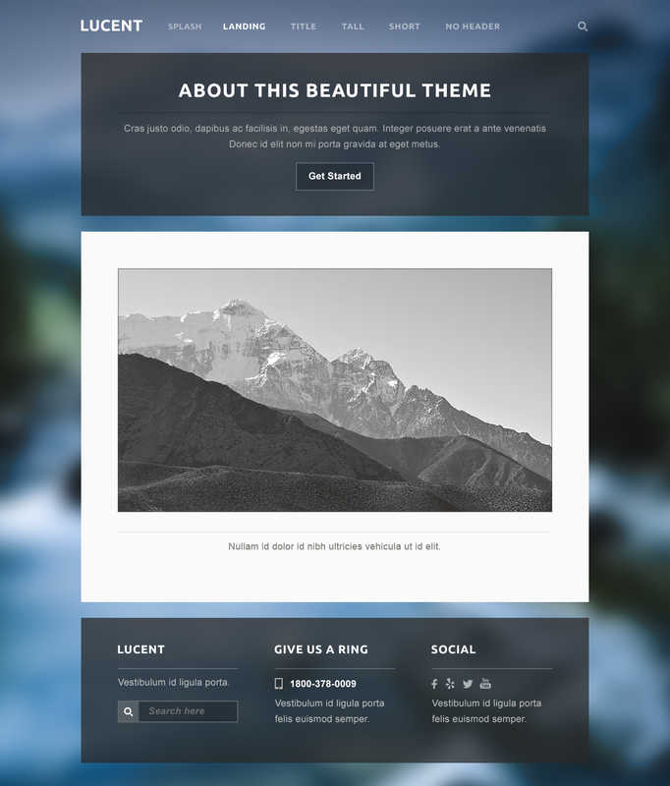
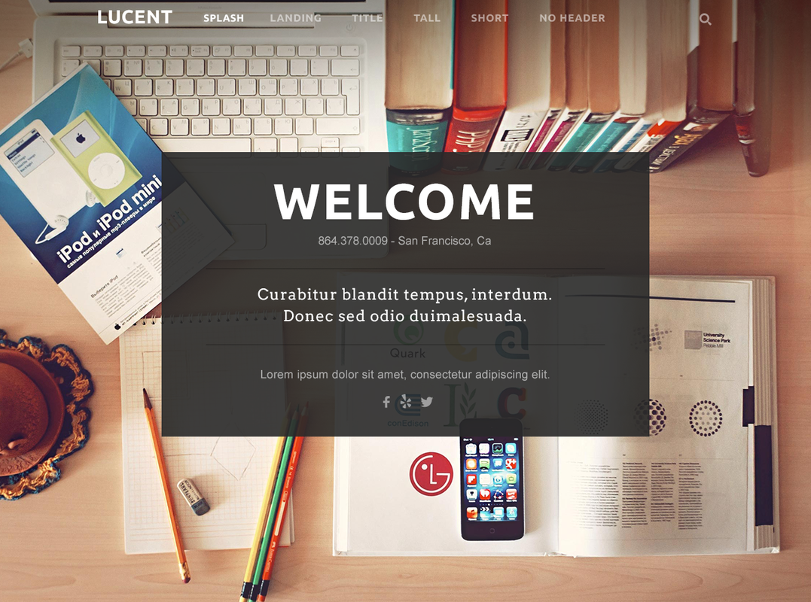
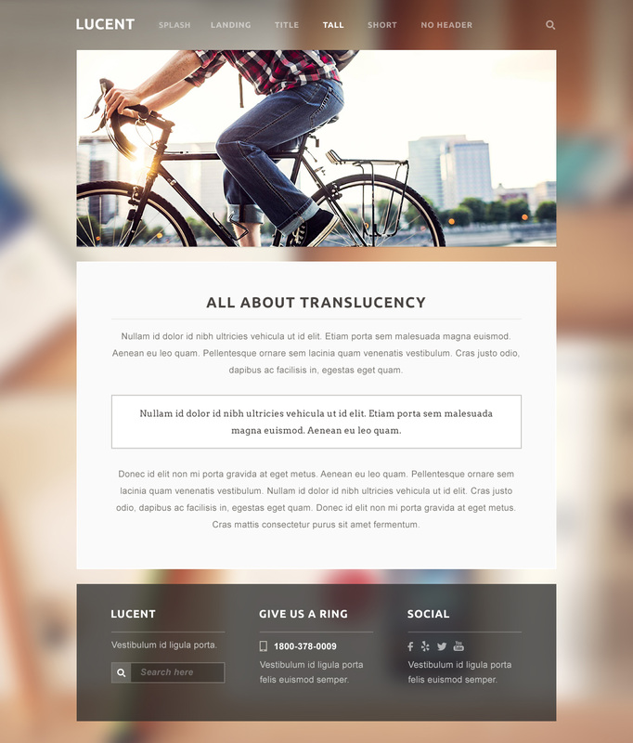
Lucent is great for anyone who wants to use images or photography to strongly convey their messaging. Whether you run a coffee shop or wish to showcase artwork - this theme loves images.
To give Lucent a spin, easily change your theme under Design > Change Theme.
Check back tomorrow or follow us on Instagram @Weebly to see the next awesome theme release!

