Elections
Elections are the process by which people vote for the candidate or proposal of their choice. The basis of democratic government is that citizens have the right to choose the officials who will govern and represent them. Elections are one of the most important political activities. Elections also serve as a means of peacefully transferring power from one person or group to another.
Democratic countries hold free, fair, and competitive elections to select elected representatives. Experts often analyze the nature and quality of elections as one characteristic of democratic control. However, other countries may include the words democracy or republic in their name without allowing free, fair, and competitive elections. The only candidates allowed on the ballot are those approved by the leaders or by a single political party. In such countries, elections are held for propaganda reasons and to demonstrate popular support for the government.
In addition to public elections, nongovernmental elections are also held to select the officials of many organizations. Labor unions, social clubs, and the student bodies of schools hold elections to select their officers.
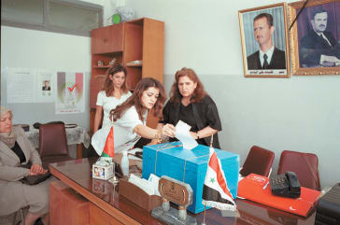
Syrian women voting in election

Elections in a democracy

Election procedures differ from country to country. However, certain principles characterize elections in democratic nations. In the United States, Canada, and other democratic countries, nearly all adult citizens can vote. Those not permitted to vote include noncitizens, such as resident aliens who live in the United States on a permanent basis; certain criminals; and people with severe mental illness or intellectual disability. Citizens vote by secret ballot so that they can vote without fear of how others will react. The mass media—which include radio, television, magazines, and newspapers—freely discuss the candidates and issues.
Voters elect officials by either direct or indirect elections. In direct elections, the people themselves vote for public officials. In the United States, for example, citizens vote for members of Congress and for state and local officials in this way. In indirect elections, people elect representatives called electors to choose public officials. The president and vice president of the United States are chosen through an indirect election.
Under a parliamentary system of government, also called a cabinet system, citizens elect members of the legislature. The head of state—the king or queen of a monarchy or the president of a republic—then selects a prime minister from the members of the legislature. Australia, Canada, and certain other Commonwealth nations regard the British ruler as head of state. In such nations, the governor general makes the appointment, acting as the representative of the monarch. In most countries, the head of state can appoint only the leader of the majority party in the legislature or the head of a coalition of parties.

