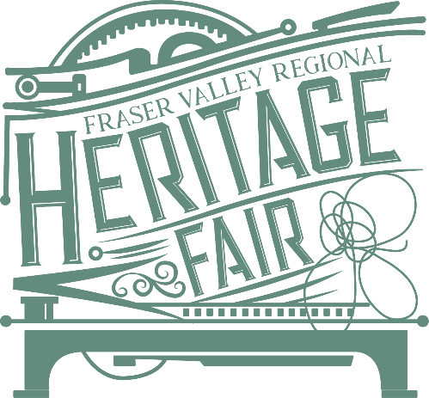

The primary goal of Social Studies education is to give students the knowledge, skills, and competencies to be active, informed citizens who are able to think critically, understand and explain the perspectives of others, make judgments, and communicate ideas effectively.
Through their study of historical events, students will gain an understanding of the people, places, issues, and events that have shaped the world they live in. By studying some of the many different cultures and ways of life that exist and have existed throughout the world, students will develop both a deeper understanding of the differences between peoples and an appreciation of the aspects of human experience shared across time and space.
Province of BC; Social Studies Curriculum: https://curriculum.gov.bc.ca/curriculum/social-studies/introduction

Heritage Fairs: the Curriculum Connection

Teachers may look for ways to connect learning with the provincially prescribed curriculum:
“B.C.’s new curriculum helps students learn by exploring their interests and passions. Whether it’s computers, hockey, or art, passion is a motivator for students, and students can connect with their interests to excel in the classroom.”

Heritage Fair participants choose any topic in Canadian history to explore then follow the steps of the Historical Thinking Method to explore the topic, and present their discoveries to the public.

“Every student will get hands-on experience in collaboration, critical thinking and communications – skills they’ll need to succeed in college, university and the workforce.”

Students build important critical and creative thinking skills in crafting an inquiry question, finding sources to answer their question and presenting their research in a creative display. They develop their ability to impart and exchange stories and ideas about Canada’s past, moving towards increasingly sophisticated ways to communicate complex ideas.

“Personalized learning is at the heart of the new curriculum.”

Students connect their personal stories to the larger stories of the community and country. They acquire a positive and healthy awareness, understanding and appreciation of the diversity of Canada’s pluralistic society while becoming confident in their ideas and what they can accomplish.
For more information on Heritage Fairs and the BC curriculum:
http://bcheritagefairs.ca/heritage-fairs-and-the-bc-curriculum/

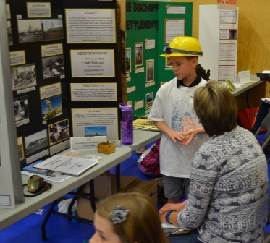
The 2020 FV Regional Heritage Fair is coordinated by The Reach Gallery Museum Abbotsford. The Regional Fair will be held at the University of the Fraser Valley, Abbotsford Campus on Thursday, May 7th (judging day) and Friday, May 8th (evening Awards Ceremony) with 120 participants representing schools from throughout the Fraser Valley.

The Heritage Fair is a tiered program:
Classroom/School Level
Students choose a topic of personal interest on some aspect of Canadian history. They take on the role of historian, interpreter, interviewer, story teller, TV producer, or artist to communicate their learning to others. Schools host their own fair in the early spring. Adjudicators select a designated number of students to attend the Regional Heritage Fair.

Regional Level
The Regional Heritage Fair is a one day exhibition for student delegates from throughout the Fraser Valley held at UFV. The program includes project judging, heritage workshops, a campus tour, and culminates in an awards assembly held the following evening. A select number of students will be chosen to attend the Provincial Heritage Fair.

Provincial Level
The BC Heritage Fairs Society organizes the five-day Provincial Fair. Delegations from each of the thirteen Regional Fair sites attend with their chaperones, they engage in heritage related activities and field trips and showcase their projects to the public. The Provincial Fair is usually held in a different BC community each year. Delegates are eligible to apply to the BCHFS Alumni program.

Getting Involved
- Decide to participate at your next school planning meeting.
- Select a date for your School/Classroom Fair: Heritage Week in February is ideal!
- Register your school for the program with the Regional Fair Coordinator; the School Participation Form can be found on page 18 of the FVRHF Manual. The registration deadline for 2020 is January 24.
- Use available resources to guide the process on project selection, program guidelines and information for students found on the BC Heritage Fairs website and/or book a presenter to visit your school:

Easy to access resources:
Teachers Kelsey Beaudry and Tom Morton have prepared Inquiry in Action: a Heritage Fairs Teachers’ Guide to support teachers who want their students to engage in an historical inquiry project, and the BCHFS has developed Let the Search Begin, a PowerPoint presentation to assist students:
https://www.dropbox.com/sh/738915f7gz75sle/AAAB0IcaooSLEm6RLz7yzEOua?dl=0

Seven Steps to a Powerful Heritage Fair Project: http://bcheritagefairs.ca/wp-content/uploads/2016/11/7_steps_to_powerful_HF_project-revised-draft.pdf

Tips for Teachers: http://bcheritagefairs.ca/wp-content/uploads/2016/11/TipsforTeachers-HeritageFairs.pdf

For more information contact the FVRHF Coordinator:
Kris Foulds, The Reach Gallery Museum
e: kfoulds@thereach.ca t: 604 864-8087 ext 122
www.thereach.ca www.bcheritagefairs.ca

