Online Shopping Challenge!

For this activity you will need:
- A calculator
- A deck of playing cards
- An internet capable device
- A partner
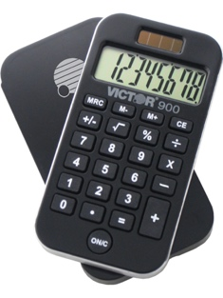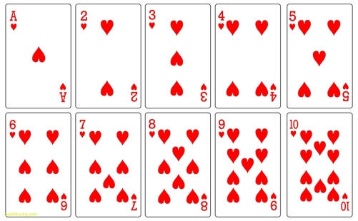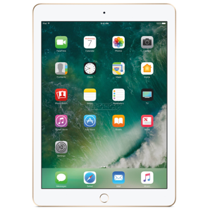

Step one. With your deck of cards…remove all of the face cards. (Kings, Queens & Jacks)

Step two. With your remaining cards, you will choose 6 cards at random from your deck. (When you choose your cards, keep them face down.)

Step three. Flip your cards face up and arrange them from greatest to least. (Aces in this case will be your LOWEST card and are treated as a 1. All other cards are the same value as on the card.)

Step 4. Once you have arranged your cards in order from greatest to least, write your number here: $ _ _ _ , _ _ _ .00

* This is the amount of money you will have to spend for your
Online Shopping Challenge! *

Step 5. The research and decision making. (You and your partner must agree on the choices!)

Using predetermined websites, you will need to purchase a number of items. (Keep track of all of your purchases on your tracking form, take screen shots of your choices, and when calculating, don’t forget taxes!)
Before you start, open a new Word Document using your Office 365 account, and attach photos / screen shots of each of your purchases. Name your document “Your Names+ Online Shopping Challenge”

Ex: Bob and Doug’s Online Shopping Challenge

Here are the websites you will need to use & the items you will need to purchase with your amount from Step 4.

- Using www.realtor.ca you will need to purchase a place to live. (It must be a minimum of 2 bedrooms and 2 bathrooms and must be in Langley.)

- Using www.autotrader.ca you will need to buy a vehicle that is no more than 10 years old, and has no more than 100,000km. (It can be any make or style, but needs to be able to fit you, your partner and a couple of friends.)

- Using www.thebrick.com you need to buy furniture for your home. You will need to buy a sofa, a coffee table, a dining table and chairs, two beds, two mattresses, two desks and two dressers.

- Using www.bestbuy.ca you need to buy a television, and two computers.

- Using www.walmart.ca you need to buy 2 sets of bedding, a set of dishes, and cutlery.
ONLINE SHOPPING CHALLENGE TRACKING FORM

Housing: Style: _________________ Address: ______________________________________________

Property Cost: _________________
+
Realtor fee: (cost x 0.03) _________________
+
Property Taxes: (cost x 0.07) _________________
=
Total Cost of the Housing: _________________

Vehicle: Style: _________________ Brand and Make: ________________________________________

Vehicle Cost: _________________
+
Taxes: (cost x 0.12) _________________
=
Total cost for Vehicle: _________________

Furniture: Sofa: ________________________________________

Sofa Cost: _________________
+
Taxes: (cost x 0.12) _________________
=
Total cost for sofa: _________________

Coffee table: __________________________________

Coffee table cost: _________________
+
Taxes: (cost x 0.12) _________________
=
Total cost for Coffee table: _________________

Dining table & chairs: ___________________________

Dining table & chairs cost: _________________
+
Taxes: (cost x 0.12) _________________
=
Total for Dining table & chairs: ________________
Bedroom set #1: Bed #1: ________________________________

Bed #1 cost: _________________
+
Taxes: (cost x 0.12) _________________
=
Total cost for Bed #1: _________________

Mattress #1: ___________________________

Mattress #1 cost: _________________
+
Taxes: (cost x 0.12) _________________
=
Total cost for Mattress #1: ___________

Dresser #1: ____________________________

Dresser #1 cost: _________________
+
Taxes: (cost x 0.12) _________________
=
Total cost for Dresser #1: ___________

Desk #1: _______________________________

Desk #1 cost: _________________
+
Taxes: (cost x 0.12) _________________
=
Total cost for Desk #1: ___________

Bedding #1: ____________________________

Bedding #1 cost: _________________
+
Taxes: (cost x 0.12) _________________
=
Total cost for Bedding #1: ___________

Bedroom set #2: Bed #2: ________________________________

Bed #1 cost: _________________
+
Taxes: (cost x 0.12) _________________
=
Total cost for Bed #2: _________________

Mattress #2: ___________________________

Mattress #2 cost: _________________
+
Taxes: (cost x 0.12) _________________
=
Total cost for Mattress #2: ___________

Dresser #2: ____________________________

Dresser #2 cost: _________________
+
Taxes: (cost x 0.12) _________________
=
Total cost for Dresser #2: ___________

Desk #2: _______________________________

Desk #2 cost: _________________
+
Taxes: (cost x 0.12) _________________
=
Total cost for Desk #2: ___________

Bedding #2: ____________________________

Bedding #2 cost: _________________
+
Taxes: (cost x 0.12) _________________
=
Total cost for Bedding #2: ___________

Electronics: Television: ____________________________________

Television Cost: _________________
+
Taxes: (cost x 0.12) _________________
=
Total cost for television: _________________

Computer #1: _________________________________

Computer #1 Cost: _________________
+
Taxes: (cost x 0.12) _________________
=
Total cost for computer #1: _________________

Computer #2: _________________________________

Computer #2 Cost: _________________
+
Taxes: (cost x 0.12) _________________
=
Total cost for computer #2: _________________

Housewares: Dishes: _______________________________________

Dishes Cost: _________________
+
Taxes: (cost x 0.12) _________________
=
Total cost for dishes: _________________

Cutlery: _______________________________________

Cutlery Cost: _________________
+
Taxes: (cost x 0.12) _________________
=
Total cost for cutlery: _________________

TOTAL: Housing + Vehicle + Furniture + Bedroom set #1 + Bedroom set #2 + Electronics + Housewares =

