Grade 9 Social Studies: Horrible Histories Video Project
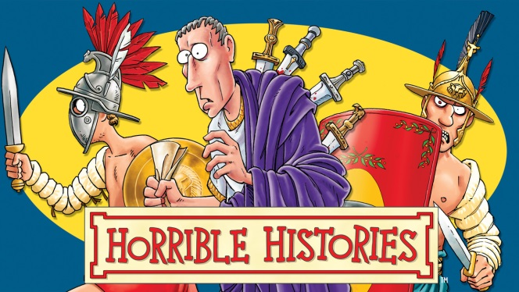
Working alone or with a partner or two, you will create a short video presentation about a historical event or figure that took place, or lived between the years 1500 – 1900 C.E.
As you have seen throughout the school year, we often watch Horrible Histories videos as part of our online class. Not only are they a lot of fun, but they provide excellent historical information in a creative and light-hearted way. For your term project, you will need to create a Horrible Histories Video of your own. You can use any video program you would like and you can work with anyone from your grade. The only thing I ask, is that you: 1) do your research… 2) be creative… 3) have fun!
Here are the guidelines and deadlines you must follow:
- You must have your TOPIC cleared by Mr. Main before: Noon on Friday, December 20^{th.}
- Your video must be between 90 seconds and 4 minutes in total length.
- Your video must include historically accurate information.
- Your video OUTLINE must be emailed to Mr. Main before: Noon on Friday, January 10th.
- Your VIDEO must be saved as a MP4 file and emailed to Mr. Main or saved to your YouTube page (please email me the link to your YouTube page) before: Noon on Monday, January 27th.
The video does not need to be live action. It can be animated, stop motion, puppets, etc.
We will have a VIDEO VIEWING PARTY on our last day of classes at the school on February 3rd.
The video will be marked on the following criteria:
Creativity /5
Organization (including adhering to deadlines) /10
Effort and Production Quality /10
Accuracy of Information /10
**I would really like to share your videos on our class website, so please let me know if you WOULD NOT like me to post it to the website at the end of the term.**

