Weekly Learning Schedule: June 1st - 5th, 2020
AT HOME LEARNERS’ DAYS WHOLE CLASS AT SCHOOL LEARNERS’ DAYS
 | MONDAY | TUESDAY | WEDNESDAY | THURSDAY | FRIDAY
09:00 – 10:00am | Warm up:  -Read the WLS 😉  -Get something to eat  -Work on your Steps 1 and 2 of the Woodblock Racer Project and have your design ready to share with your classmates during our 10am Morning Meet Up.  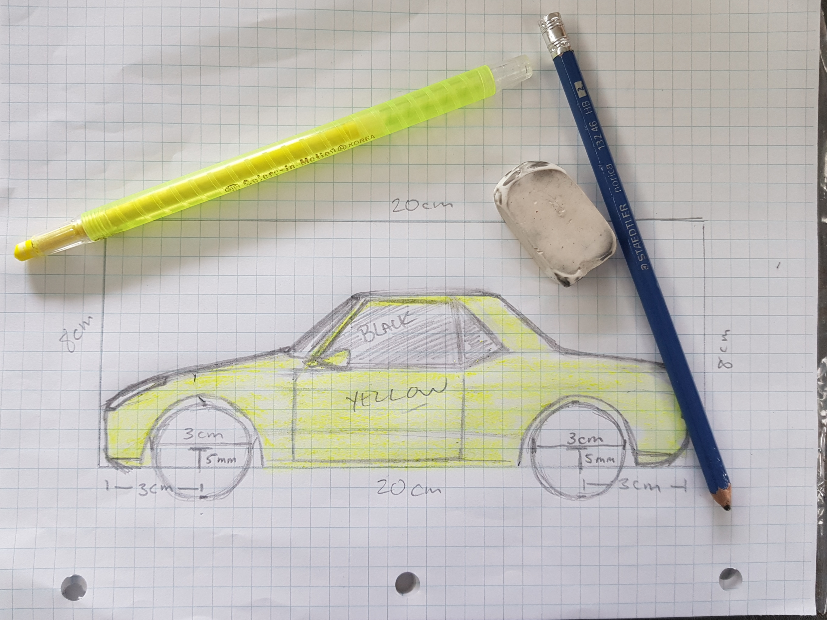 | Reading Groups:  Mischievous Monkeys 9:00 – 9:30am  Rambunctious Raccoons  9:30 – 10:00am | Numeracy: Check the Numeracy page of the class website for the link to an area and perimeter online quiz.  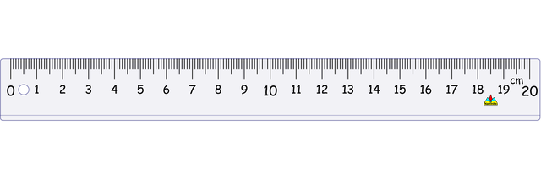The quiz will be multiple choice and will be similar in format to the fractions and decimals quiz we did in last month.  *The quiz will only be available between 9:00 – 10:30am.* | At school learning day #1:  Arrive at outside classroom door at 8:45am  Remember to bring your:  -pencil box,  -binder,  -snack,  -lunch,  -outside shoes  and  (if possible) your own computer / tablet. | At school learning day #2:  Arrive at outside classroom door at 8:45am  Remember to bring:  -Three items from home that you will draw from different perspectives.  and  (if possible) a baseball glove.
10:00 – 10:45am | Monday Morning Meet Up!  -Review WLS  -Discuss Real Estate Assignment  -Share Woodblock Racer designs  -Q/As | Jiggly Giraffes  10:15 – 10:45am | Health & Fitness: Get moving and have fun with an NBA player!  https://wideopenschool.org/programs/educator/6-12/get-moving/ | At Home Learners and their Parents can come to collect their Woodblock Racer kits between 10:20am - 12:00pm.  *Please make sure you only come at your scheduled time!* | At Home Learners and their Parents can come to collect their Woodblock Racer kits between 10:20am – 12:00pm.  *Please make sure you only come at your scheduled time!*
10:45 – 11:00am | Snack Break | Snack Break | Snack Break | Snack Break 10:05am | Snack Break 10:05am
11:00 – 11:30am | Health & Fitness: (Body Break)  Do the most recent PE with Joe workout or do Day #5 of 30 in the Yoga with Adriene series of YouTube videos.  (Click the hyperlinks  above to be taken to your Fitness Activity) | Playful Pandas  11:00 – 11:30am | Literacy: Current Events “BC man cannot enter PEI” Reading Comprehension assignment. | Lunch time will be from: 12:00 – 12:30 | Lunch time will be from: 12:00 – 12:30
11:30 – 12:00pm | -Read the CBC News Story about Face Masks then watch the associated video. The story and the video can be found on the Literacy Page.  -Once you are done reading and watching, read the opinion questions carefully, then post your opinions in the comments section of the Literacy page. | Flex: Spend some time working on your French using Duolingo!!  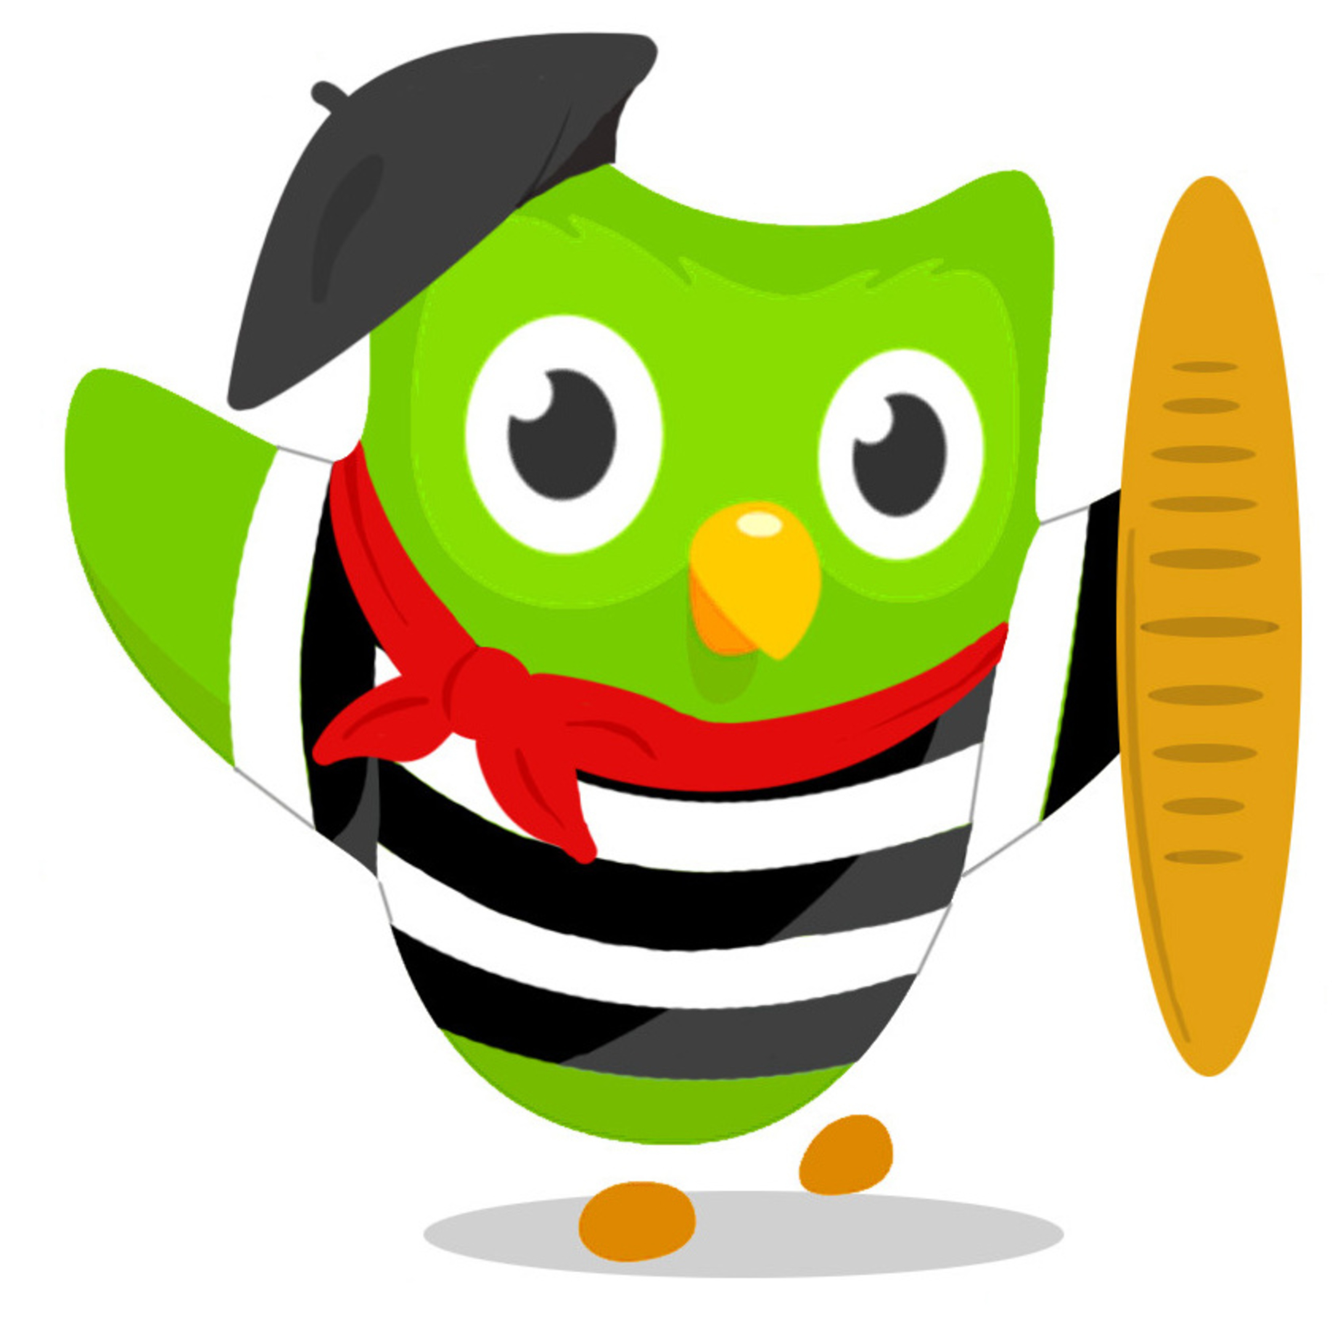 | Flex: Typing Speed!  You will need a timer, and a computer with a keyboard.  Read the story called The Muscovy Duck on the Literacy Page, then type out the text exactly as it is written. Use your timer to see how long it took you.  Post your name, your time, and the number of errors in the comments section.  Ex:Jake 2:12 & 6 errors | Dismissal will be at: 2:30pm | Dismissal will be at: 2:30pm

