Weekly Learning Schedule: June 8th - 12th, 2020
AT HOME LEARNERS’ DAYS WHOLE CLASS AT SCHOOL LEARNERS’ DAYS
 | MONDAY | TUESDAY | WEDNESDAY | THURSDAY | FRIDAY
09:00 – 10:00am | Warm up:  -Read the WLS 😉  Go to:  https://www.brainpop.com/socialstudies/ushistory/civilrights/  Watch the BrainPop  Civil Rights Movie and then do the Review Quiz and the Review Challenge Activities.  Once you are done, watch the “I Have a Dream” video on the Literacy Page. | Reading Groups:  Playful Pandas  9:00 – 9:30am  Mischievous Monkeys  9:30 – 10:00am  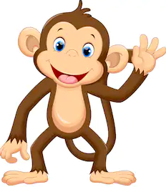 | Numeracy: Calculate the area of your Woodblock Racer in square centimeters.  See the Numeracy Page for a step-by-step explanation about how to do this.  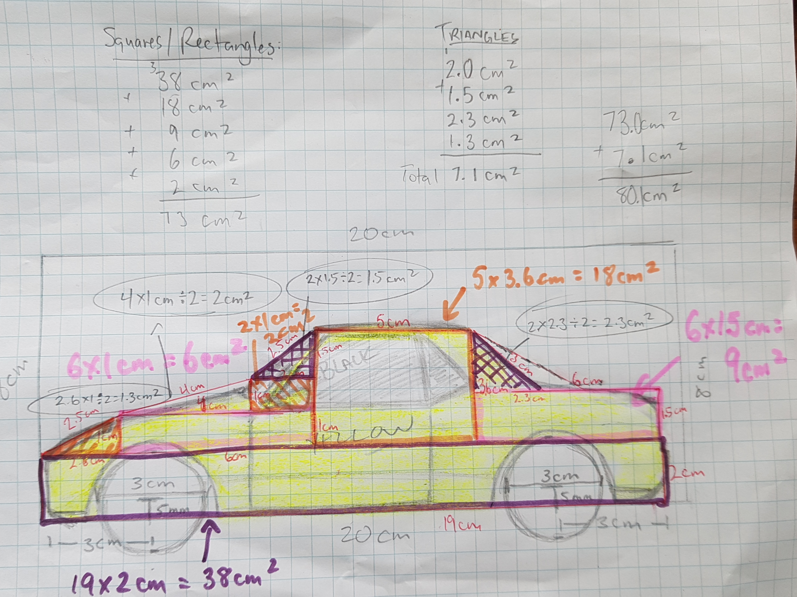 | At school learning day #3:  Arrive at outside classroom door at 8:45am  Remember to bring your:  -pencil box,  -binder,  -snack,  -lunch,  -outside shoes | At school learning day #4:  Arrive at outside classroom door at 8:45am  After we complete our morning lessons... we are planning to put together a slideshow or possibly a video of all of the class’s Woodblock Racers.
10:00 – 10:45am | Monday Morning Meet Up!  -Review WLS  -Thoughts on Civil Rights Movie and MLK  -Correct Math Quiz  -update on plans for Woodblock Racer Car Show and Race Day  -Q/As | Rambunctious Raccoons  10:15 – 10:45am  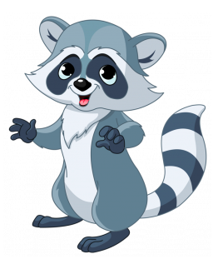 | Health & Fitness:  Choose your own Adventure!  Choose an activity of to get your heart rate racing or by take some time to rest your mind and body. | At Home Learners:  Please drop off your completed Woodblock Racers at the classroom outside door between 9am and 12pm. Please bring them in your Ziploc bag with your name on it. | At Home Learners:  If you did not drop off your Woodblock Racer on Thursdsay, please make sure you bring it to the classroom outside door by no later than 10:30am.
10:45 – 11:00am | Snack Break | Snack Break | Snack Break | Snack Break 10:05am | Snack Break 10:05am
11:00 – 11:30am | Health & Fitness: (Body Break)  Do the most recent PE with Joe workout or do Day #6 of 30 in the Yoga with Adriene series of YouTube videos.  (Click the hyperlinks  above to be taken to your Fitness Activity) | Jiggly Giraffes  11:00 – 11:30am  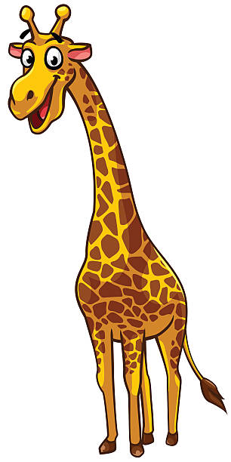 | Literacy: Current Events -Watch the CBC Kids News Story about The Black Lives Matter then read the associated story on the website. The video and the associated story  can be found on the Literacy Page. | Lunch time will be from: 12:00 – 12:30 | Lunch time will be from: 12:00 – 12:30
11:30 – 12:00pm | Literacy: Create a Venn Diagram or a T-chart comparing the similarities and differences of one of the following people we’ve read about so far in our Epic Reading Groups.  Choose two of the following three people:  1)Ernest Just  2)Lonnie Johnson  3)Malala Yousafzai  When finished...take a picture and put in your Hand In Folder. | Numeracy:  Finish reading the novel “All About Martin Luther King Jr.”  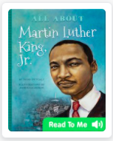  *This book also has a “read to me” feature if you would like to listen and read along.* | Flex: Art - Finish putting the final touches on your Woodblock Racer.  Also please make arrangements to drop off your racer at the school between 9am – 12pm on Thursday.  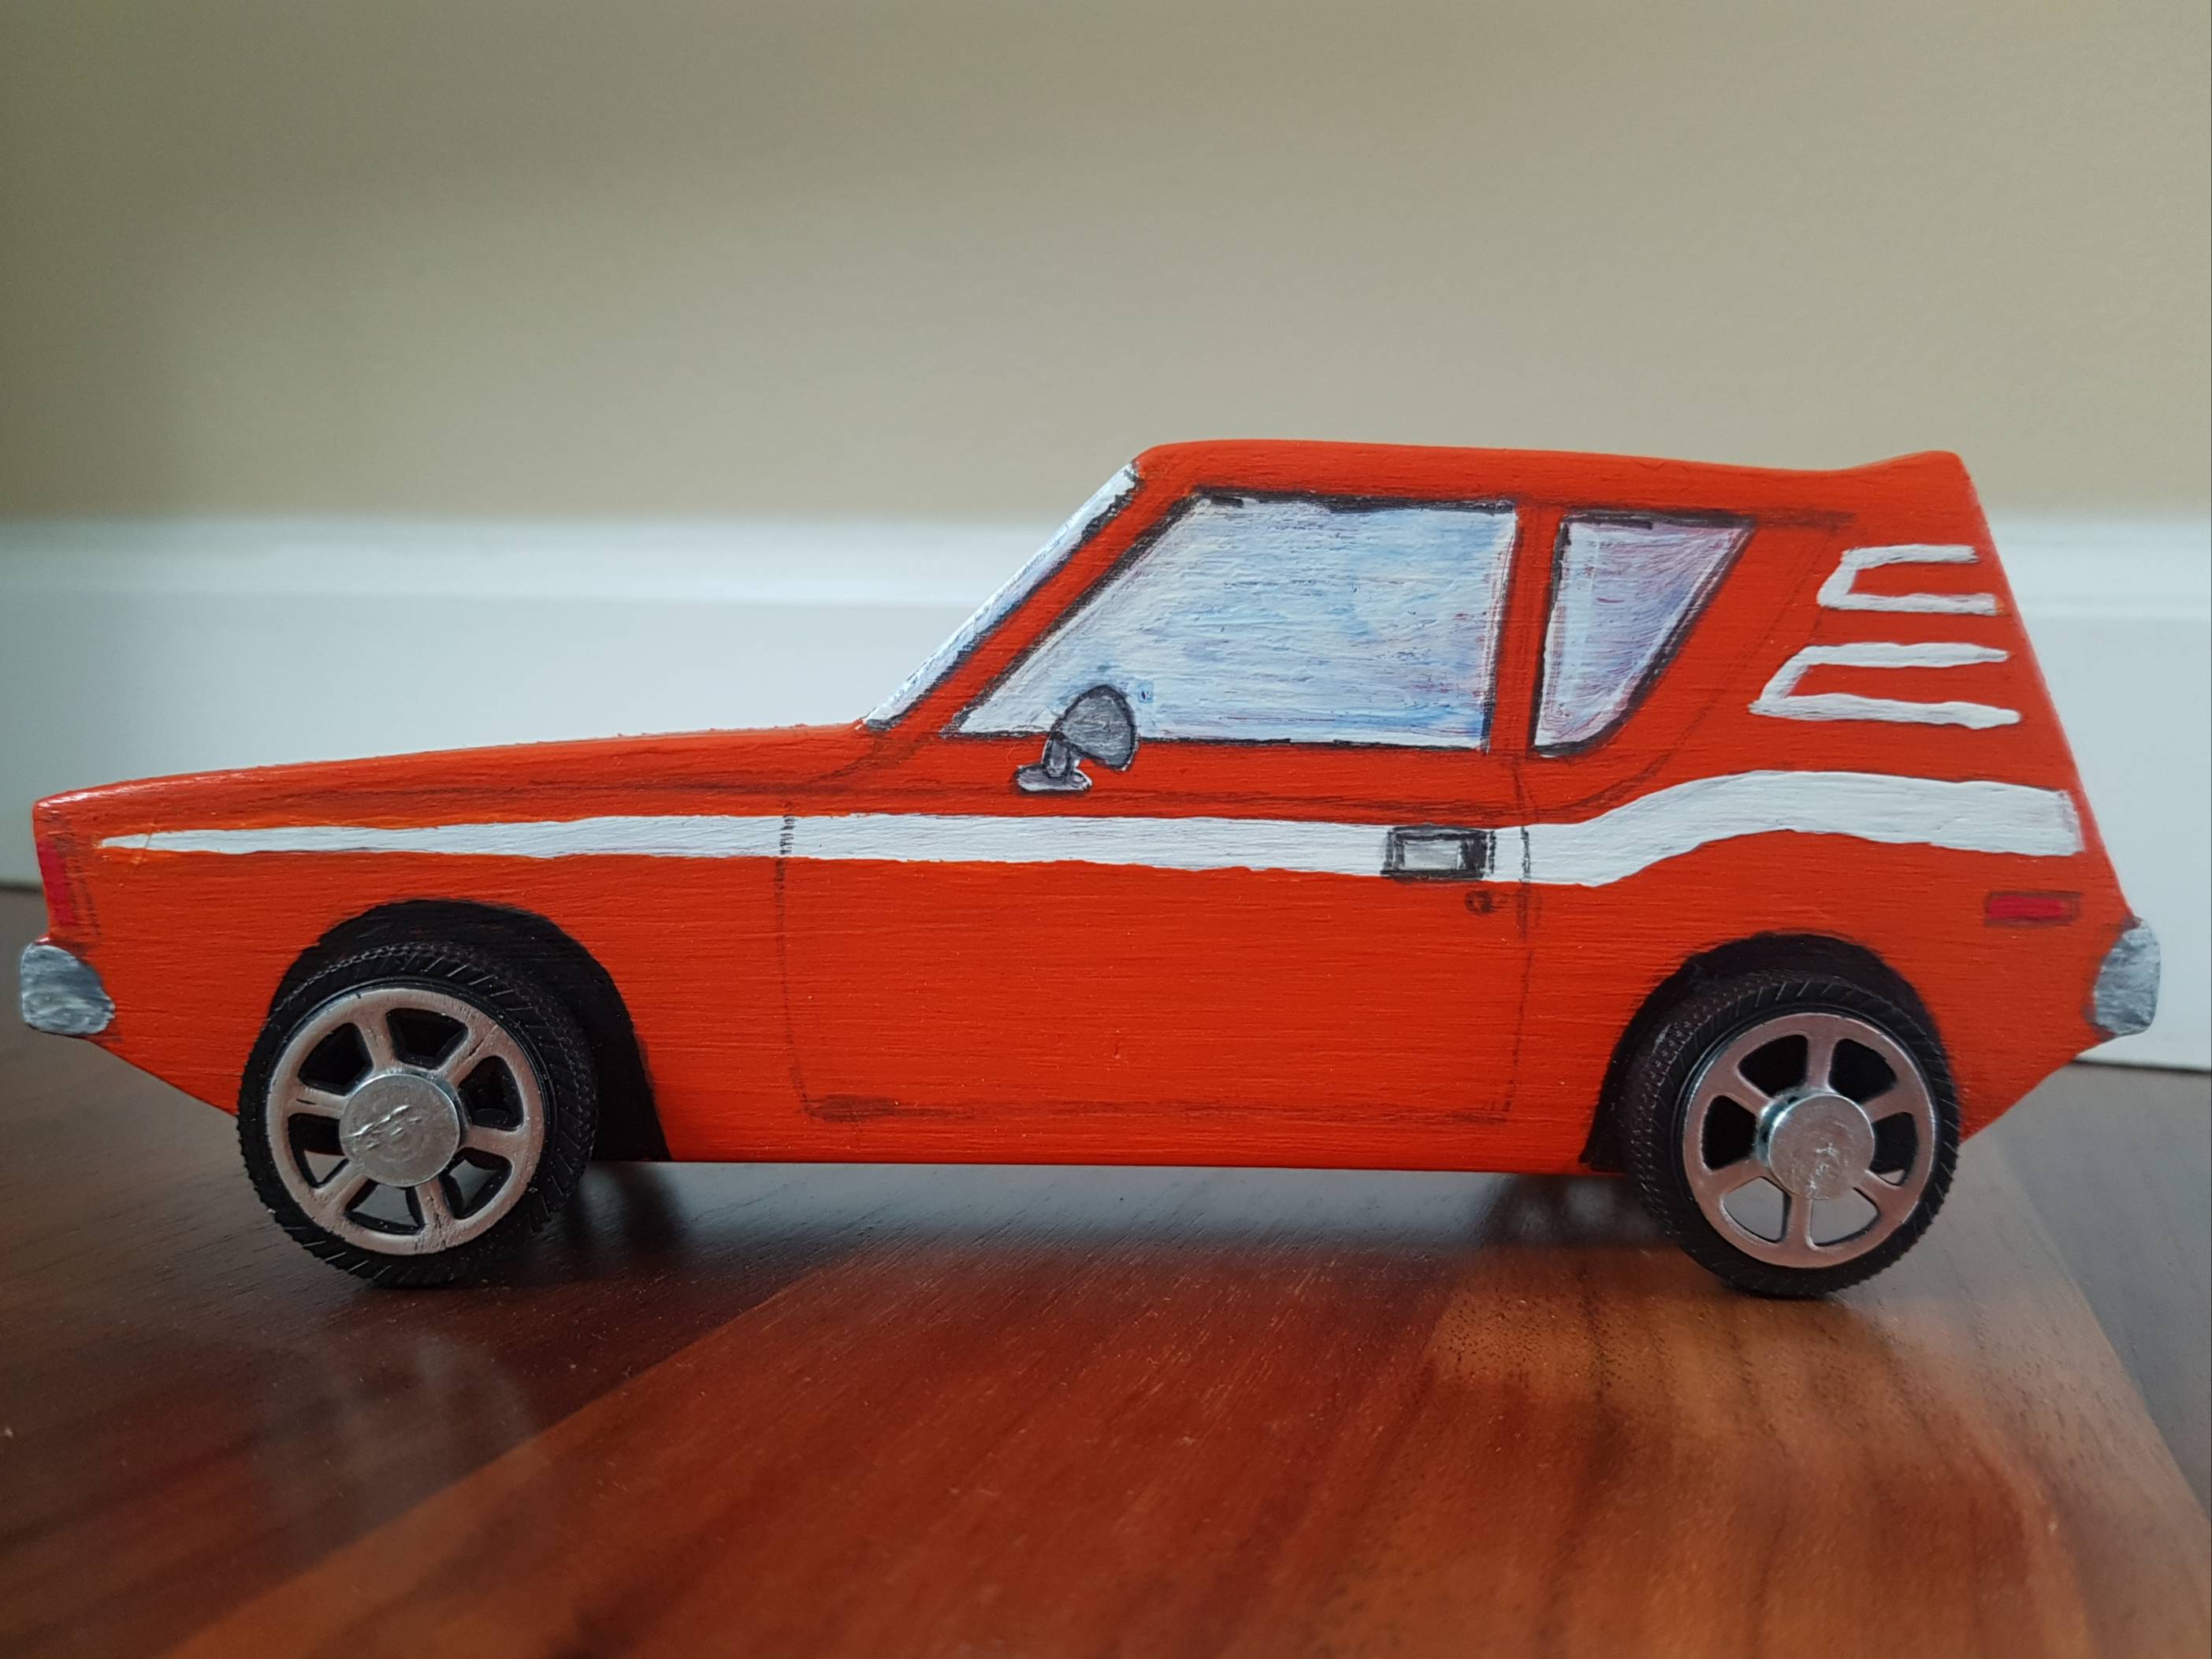 | Dismissal will be at: 2:30pm | Dismissal will be at: 2:30pm

